# Creating a pipeline

Create a free account at dev.azure.com

Create a new project.

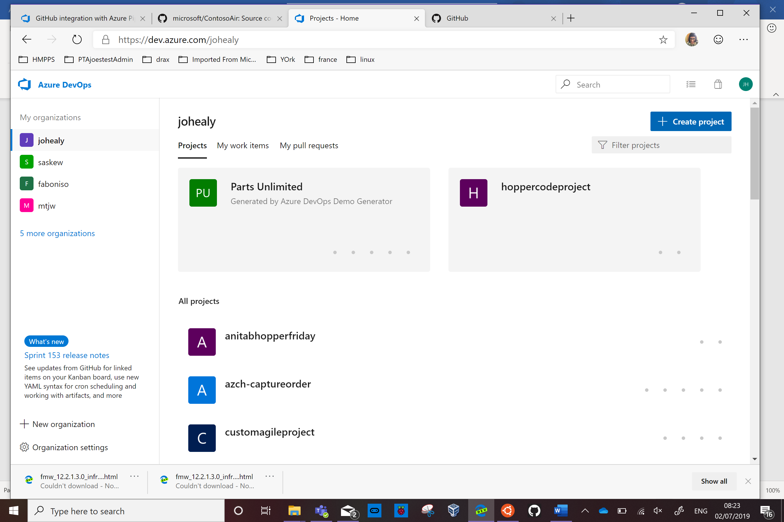



Leave it as the default, Private, so only people you invite can see it.

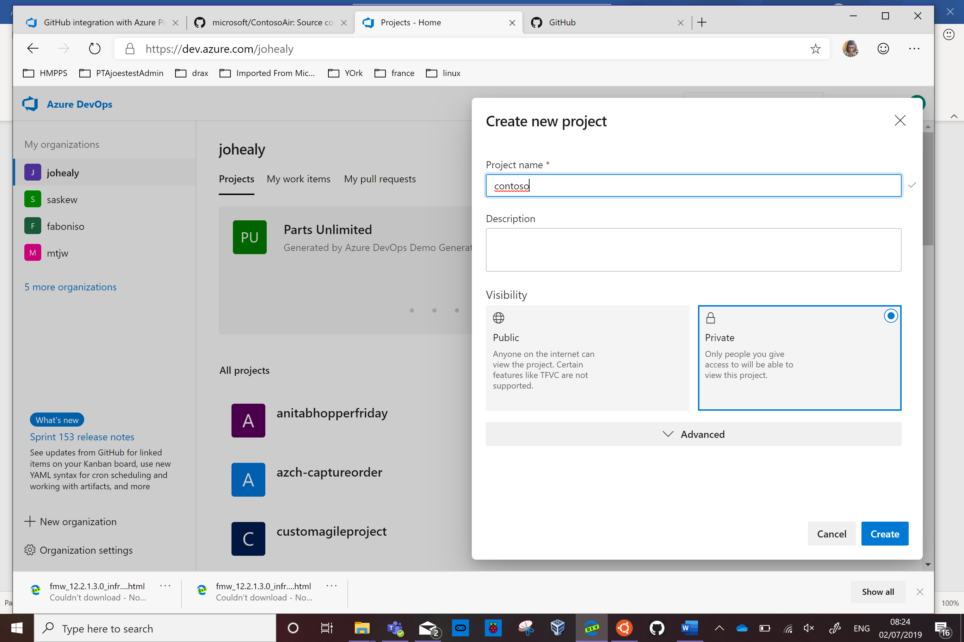

Click Create.

Click Project Settings on the bottom left of the screen

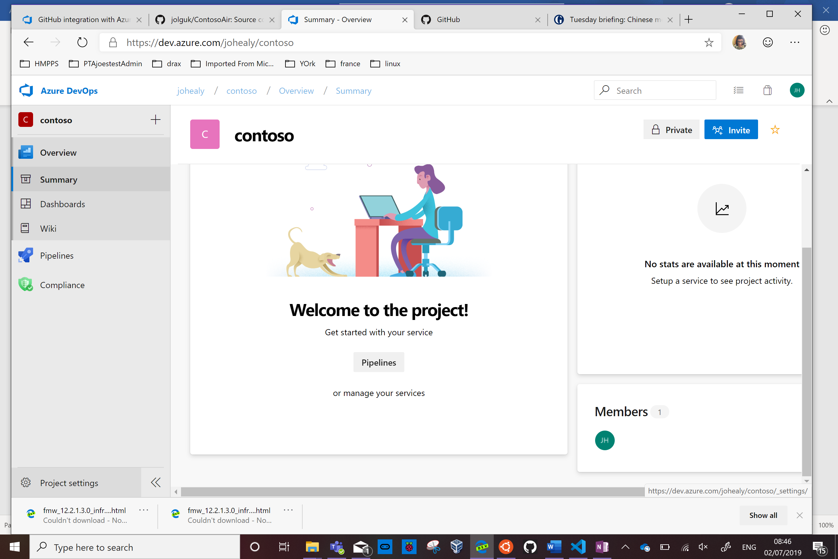



Scroll down to the bottom of the screen and toggle on Repos and Boards.

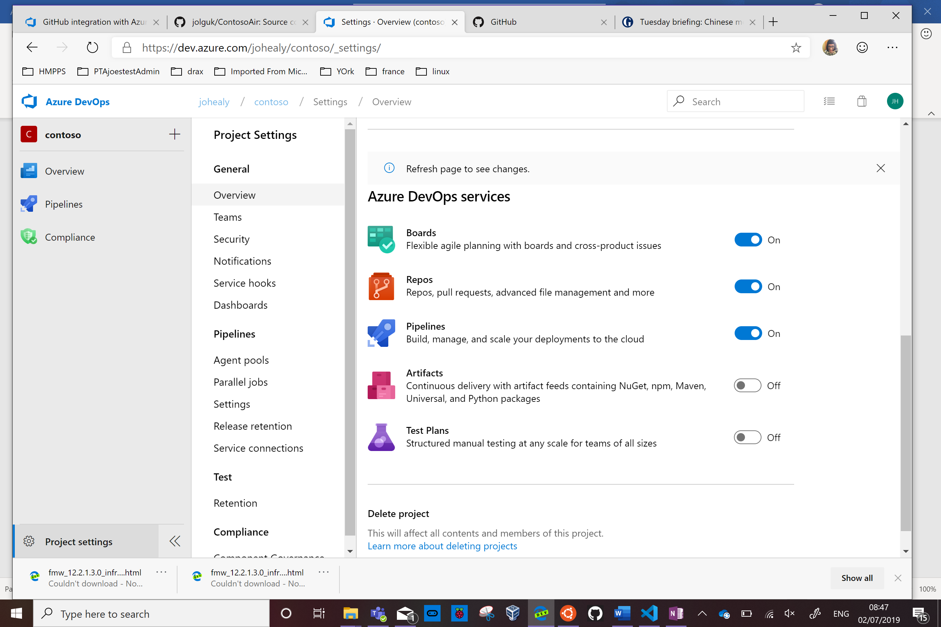



Click Overview on the top left to refresh the view.

Click Repos

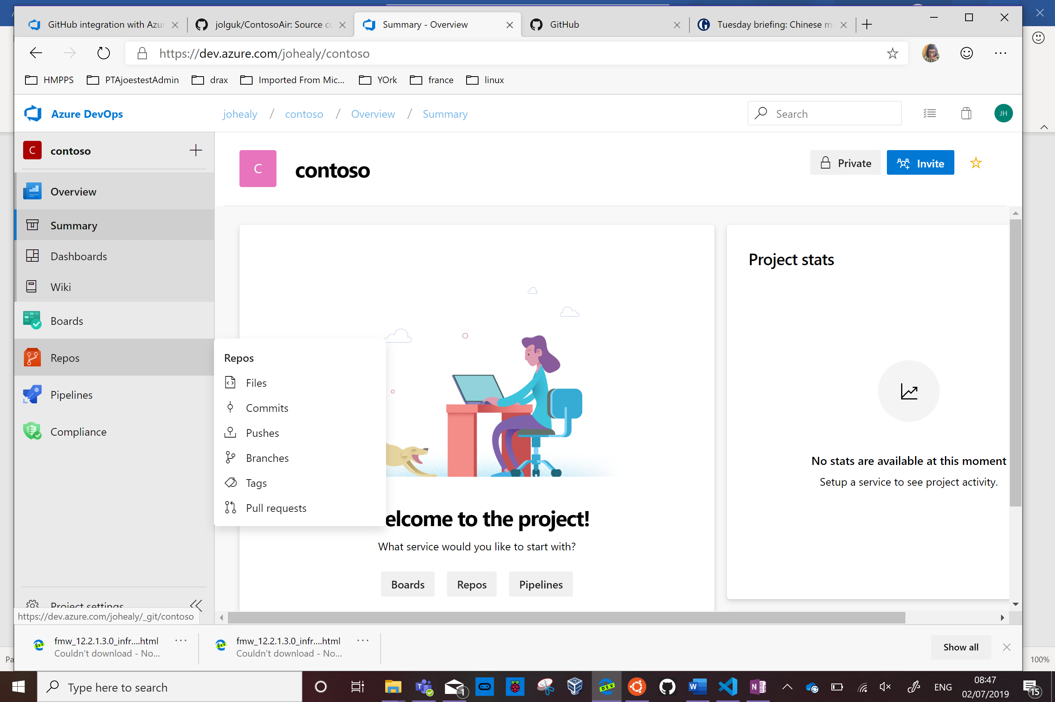

Click import

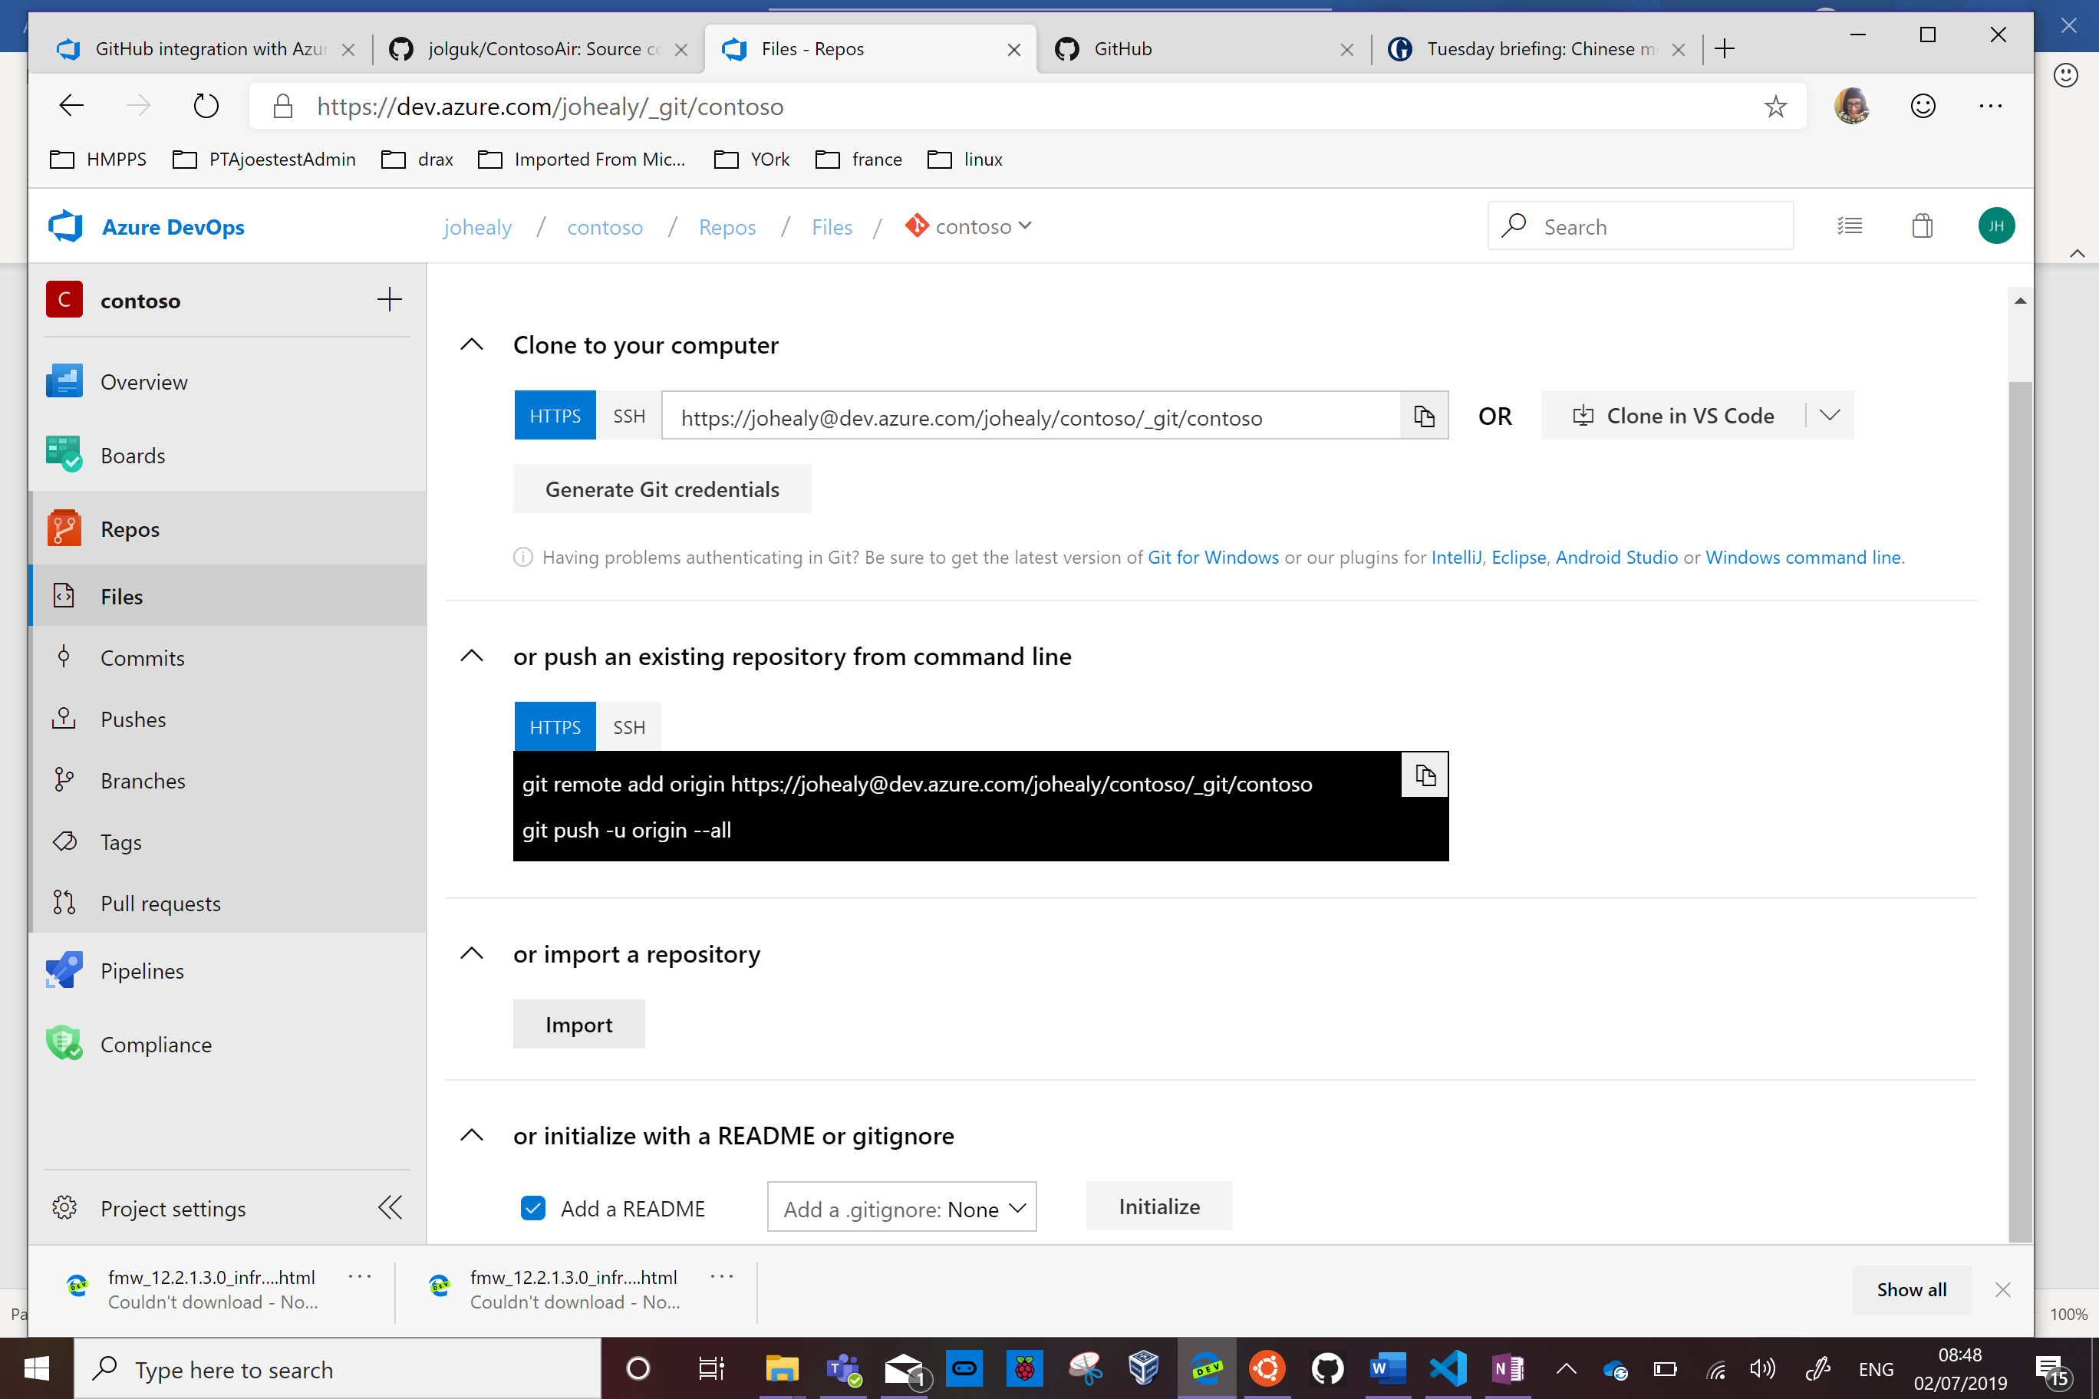



Enter <https://github.com/jolguk/ContosoAir.git> as the repo to import

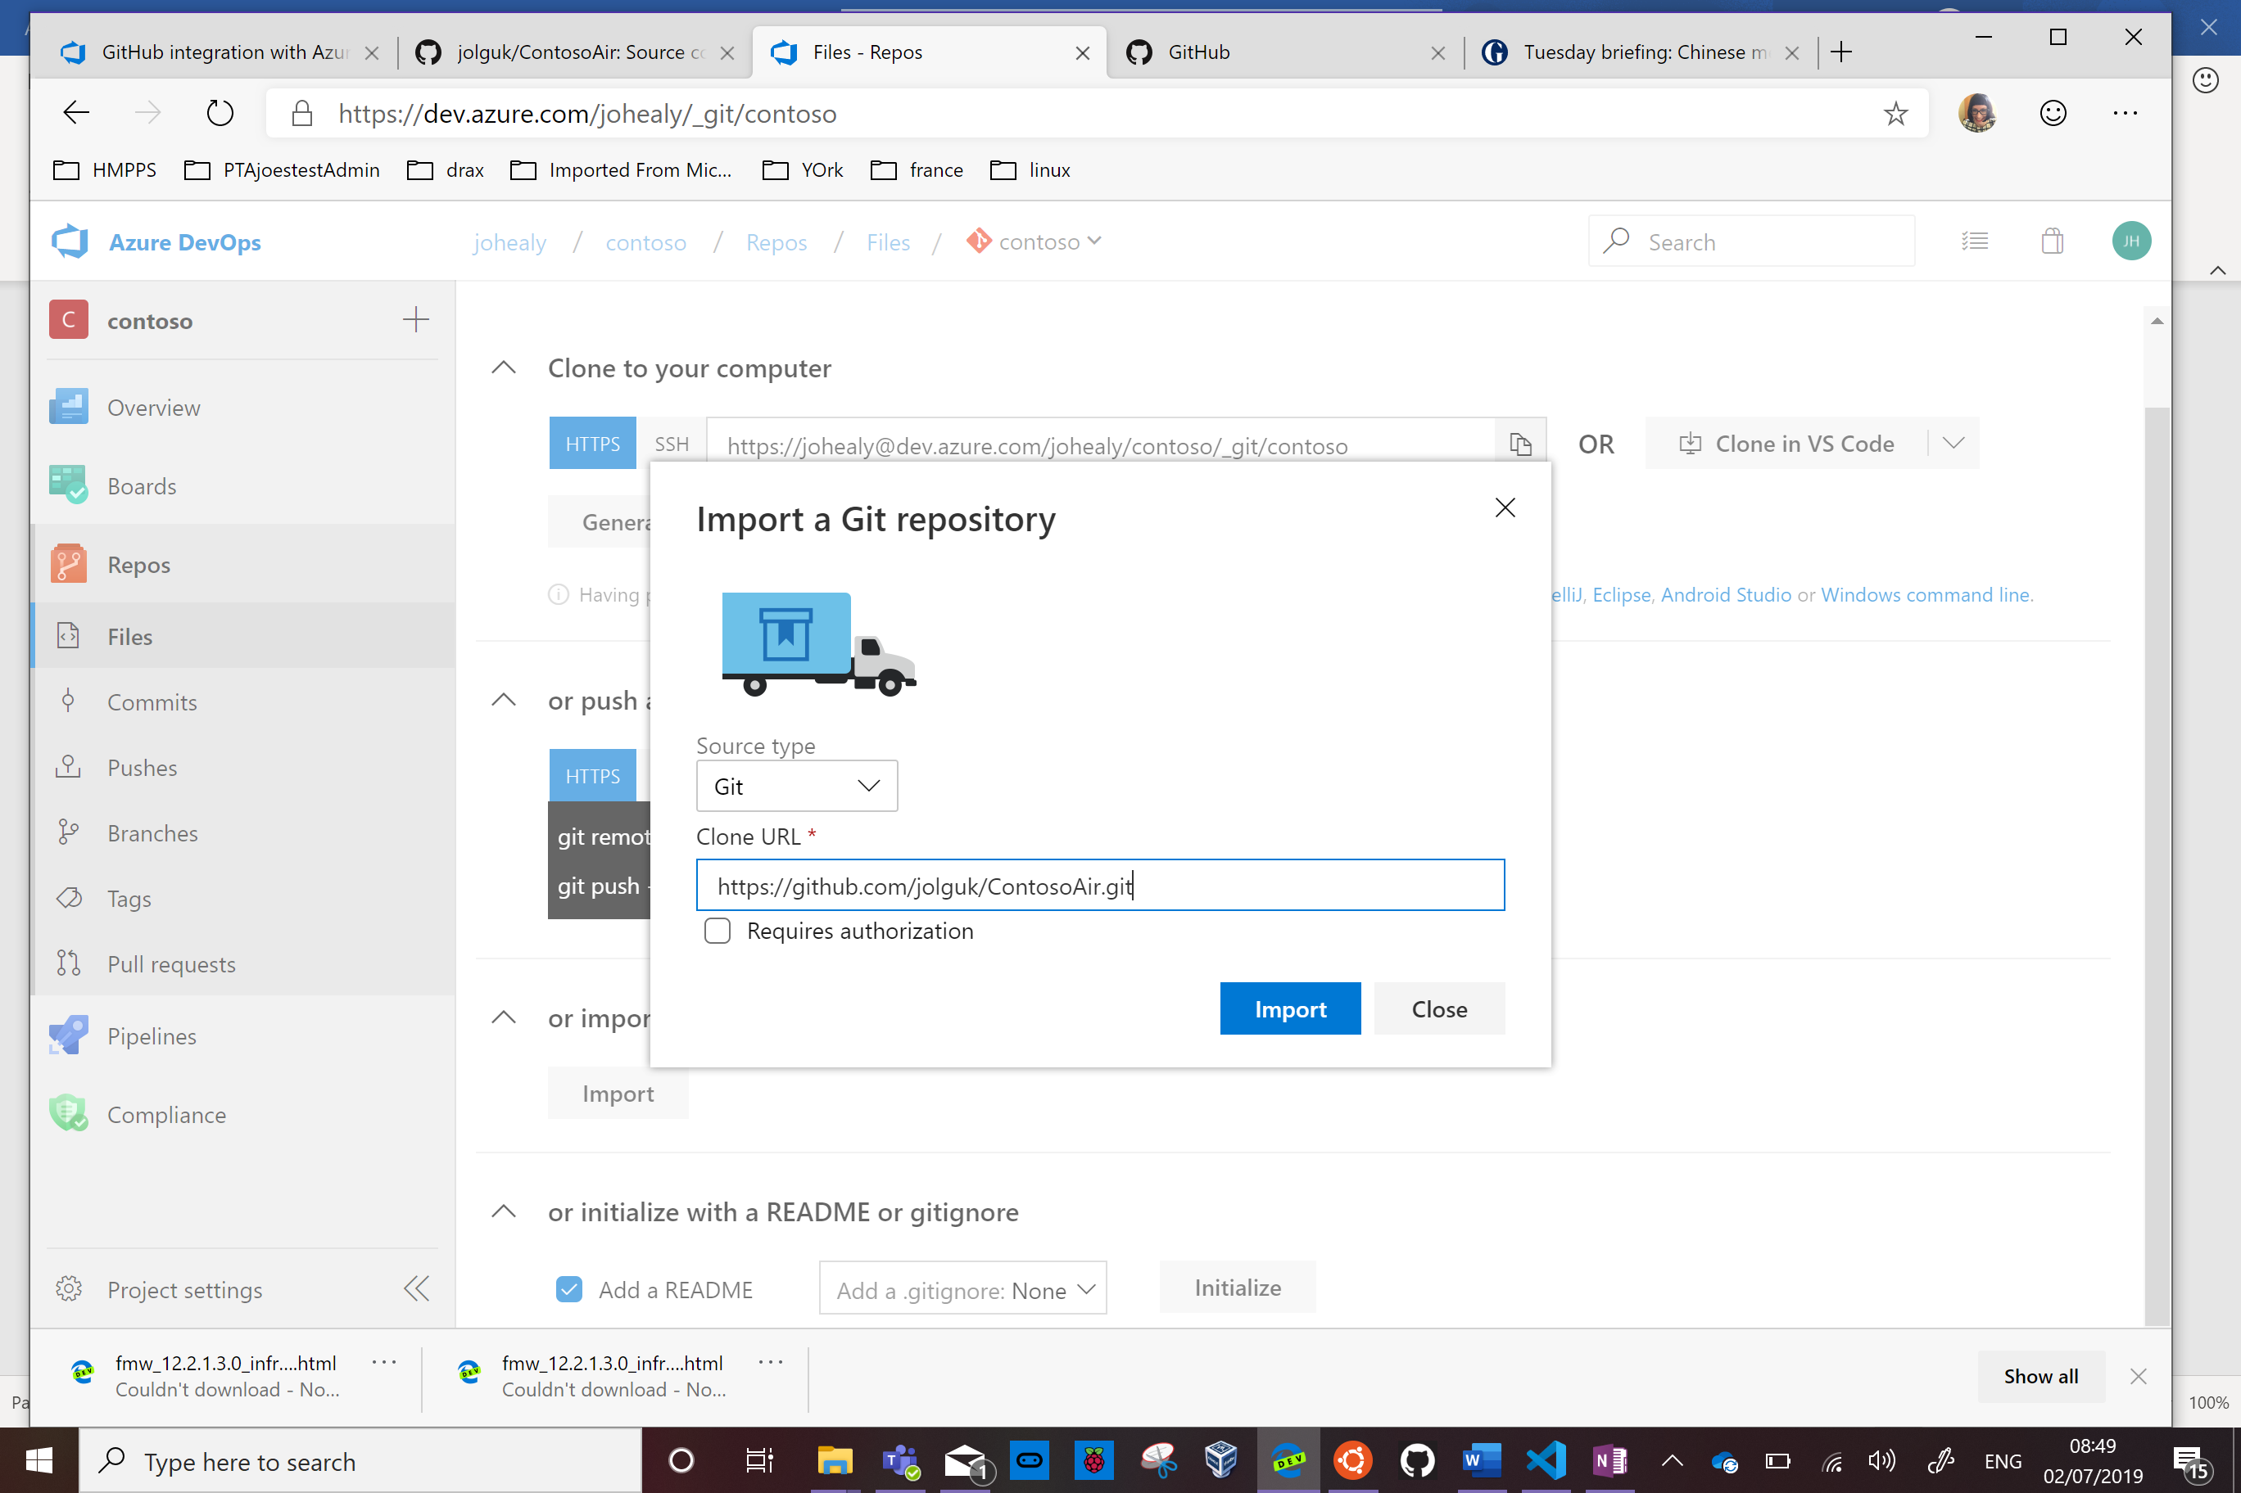



Click Import

Once it’s complete it will show a view of your repository. This includes an azure-pipelines.yml file.

Click pipelines on the bottom left

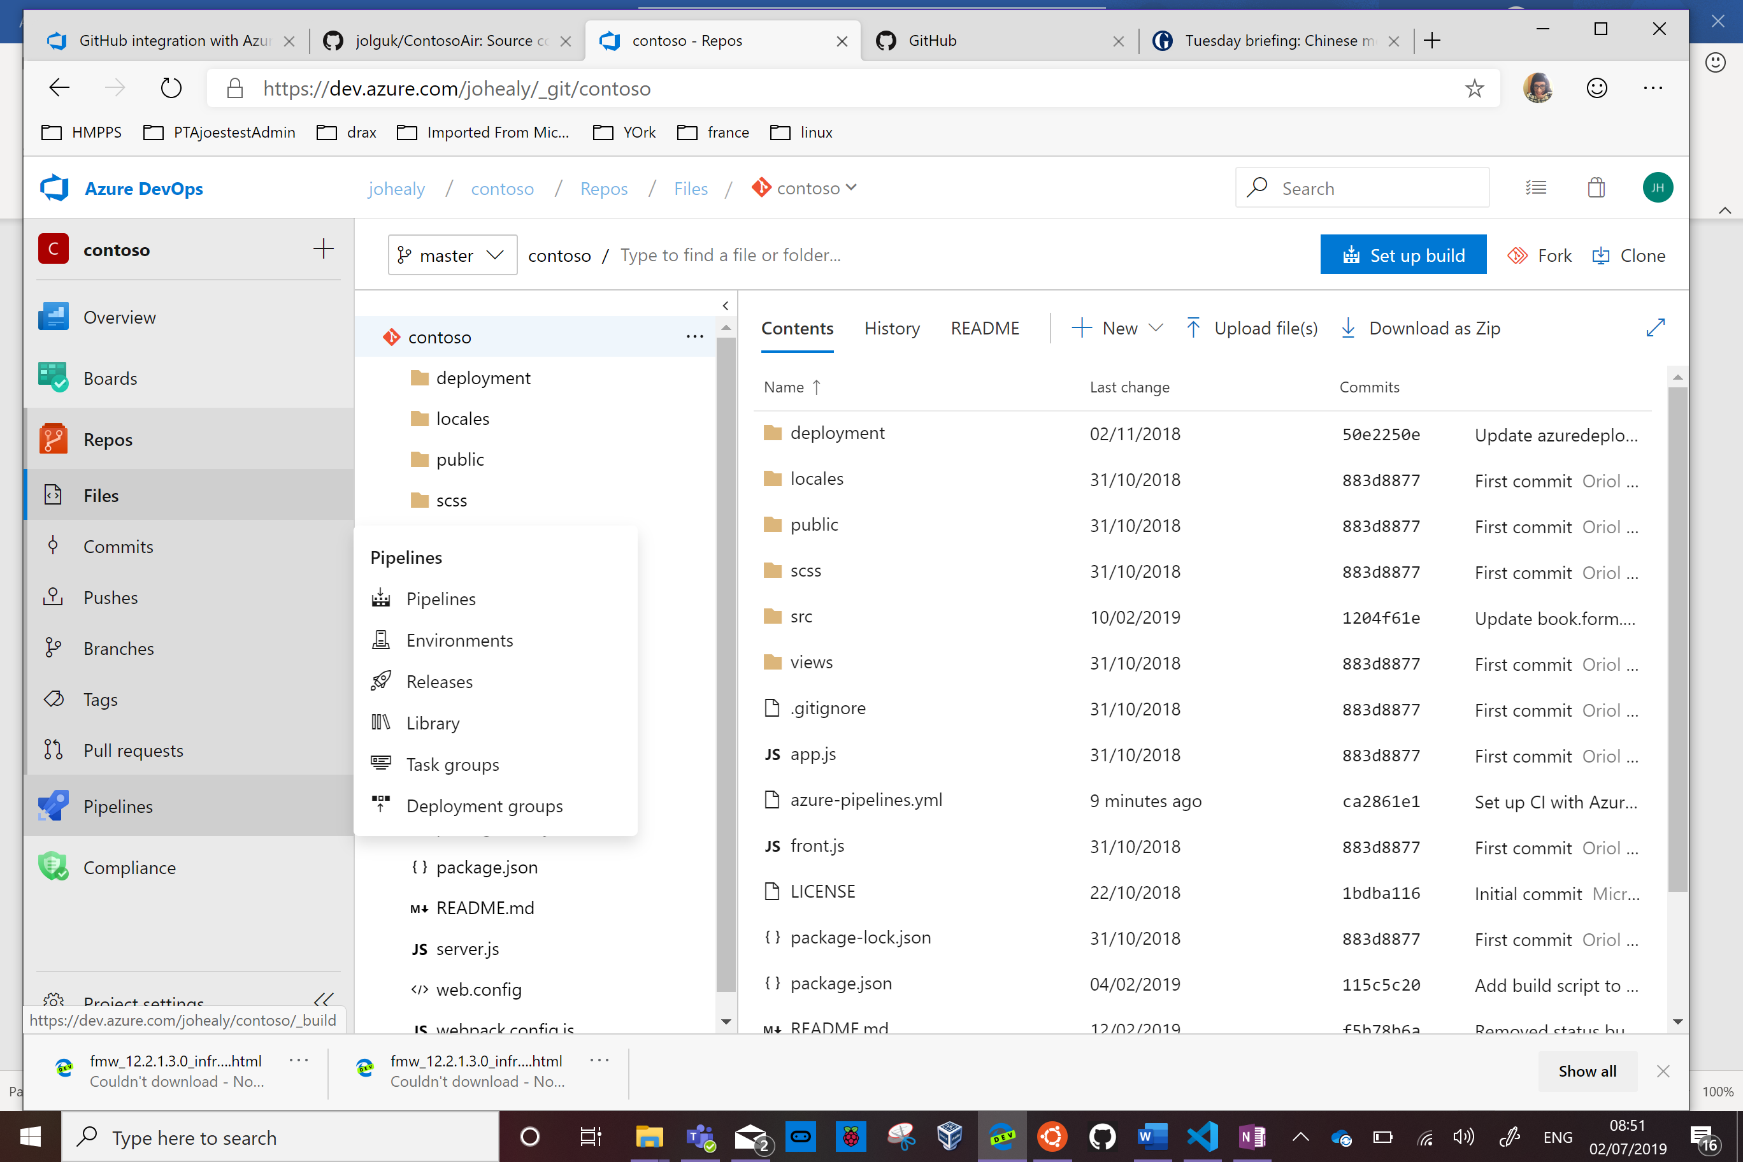

Click Create Pipeline.

On the Where is your code? Page click Azure Repos Git

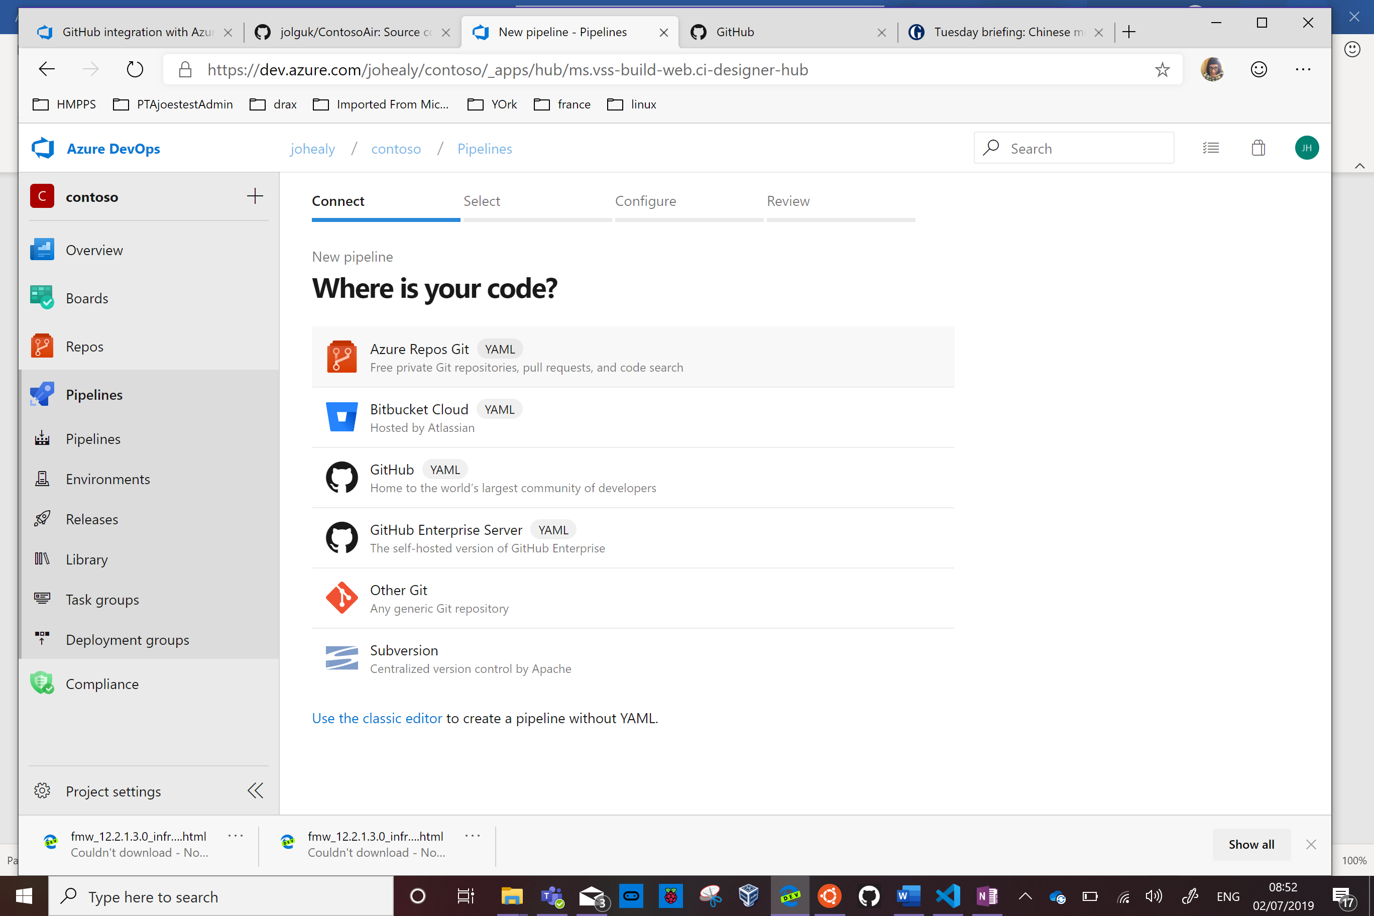

Click on your repository

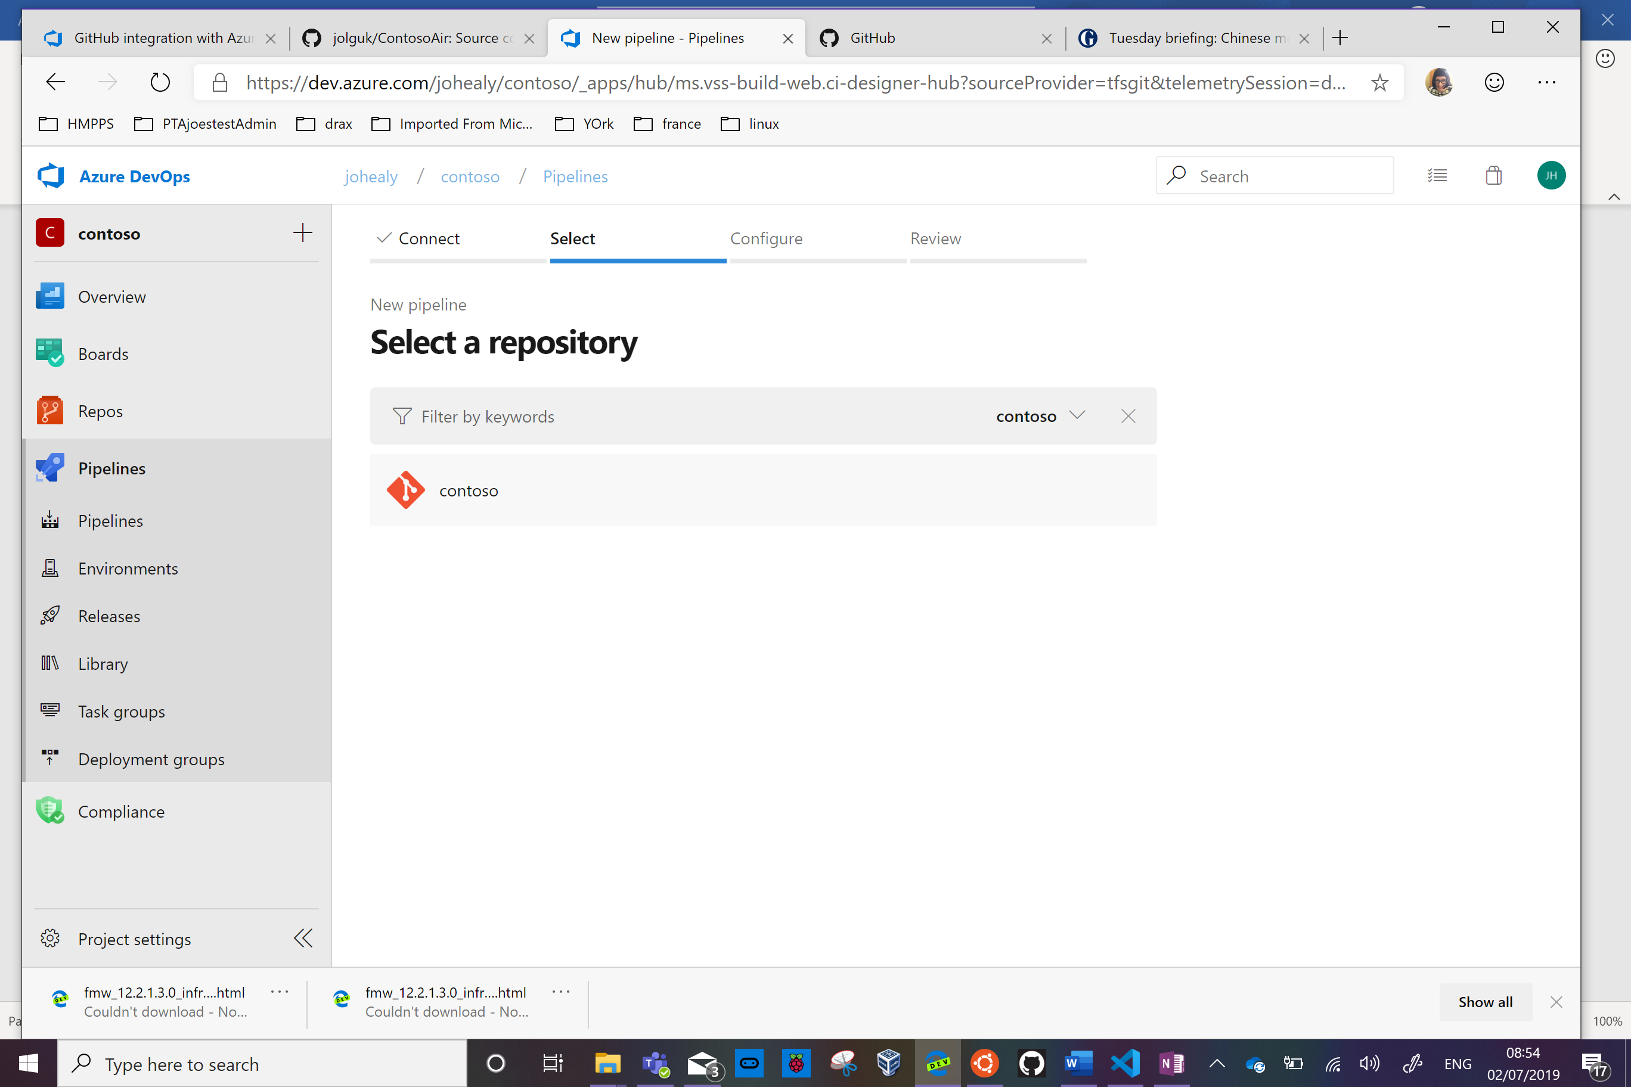



Click Run

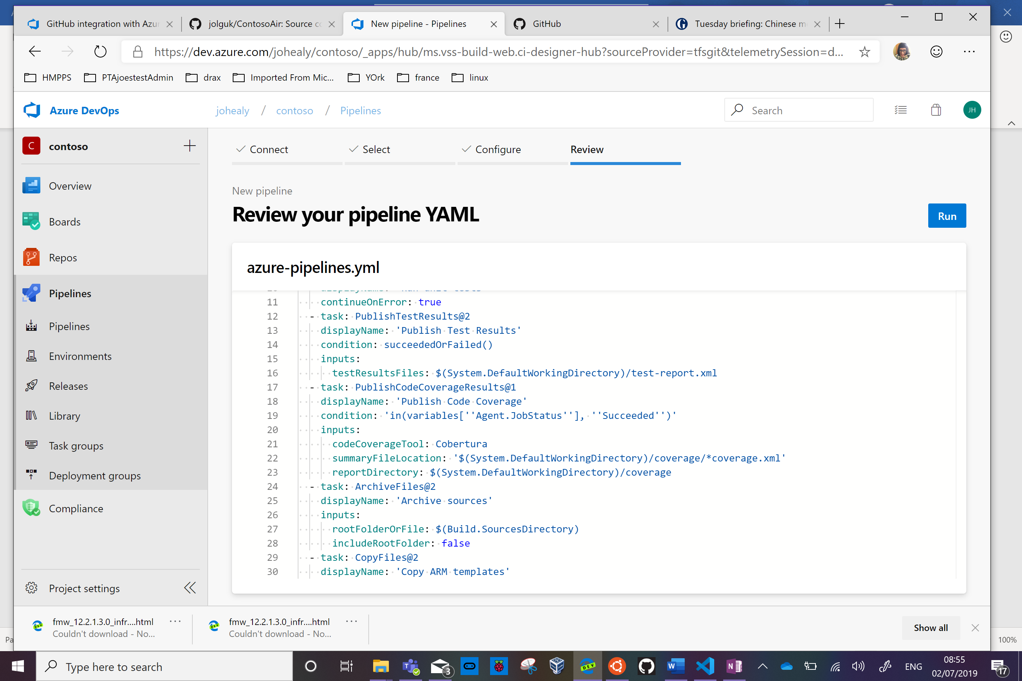



Click on Job to see the build progress

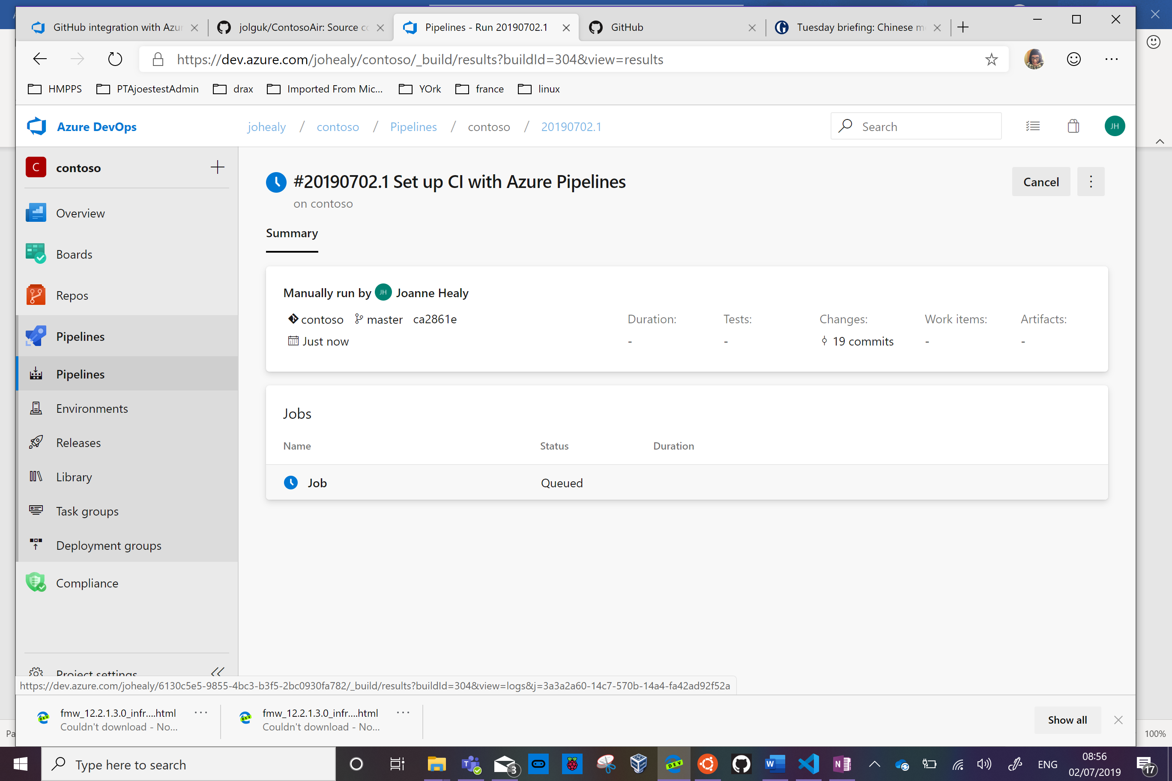



Once it’s finished the job will have a green background and a tick

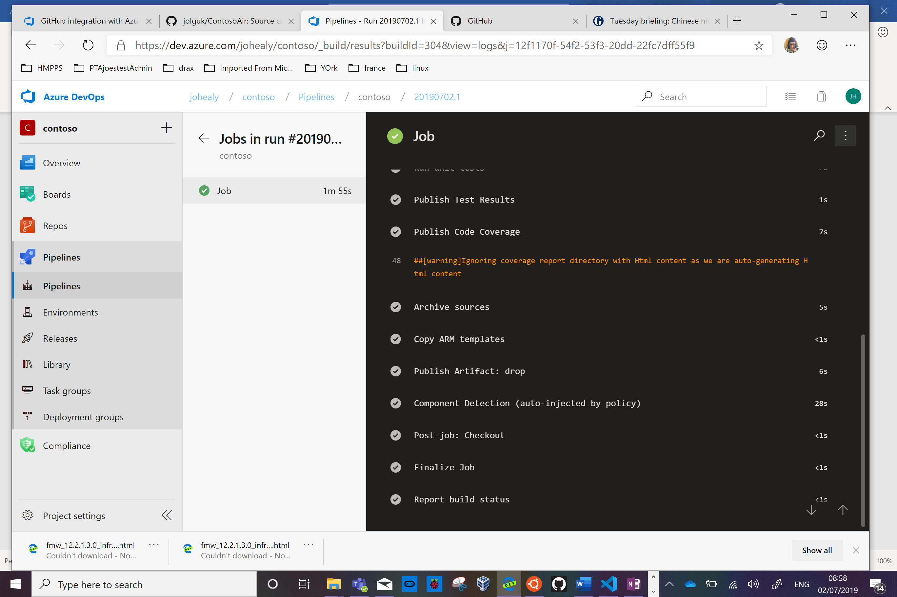



Now build a release pipeline.

Click Pipelines then Releases

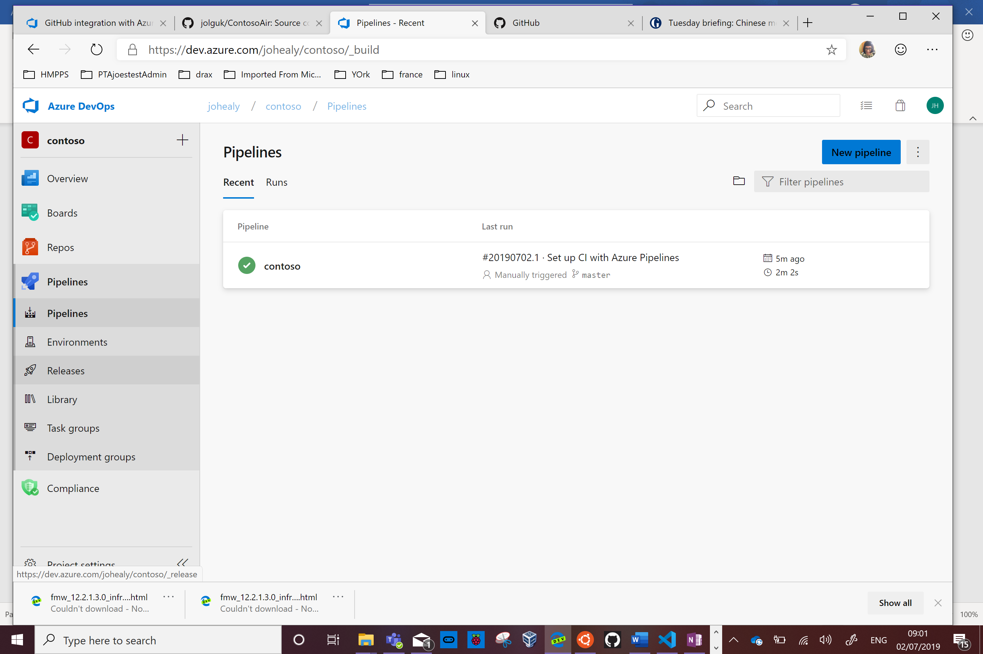



Click New Pipeline

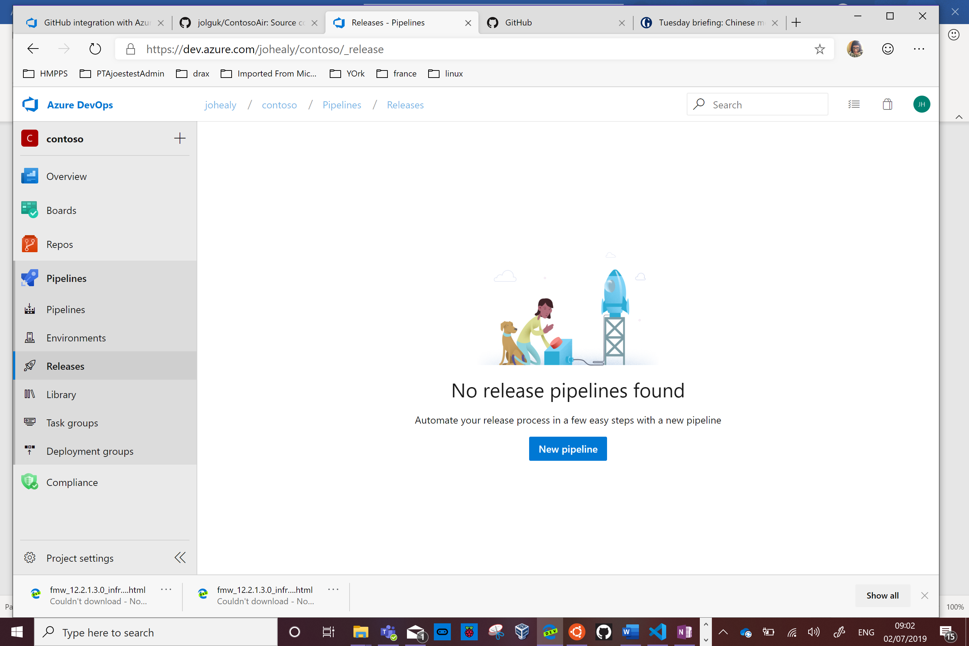

Click Empty Job

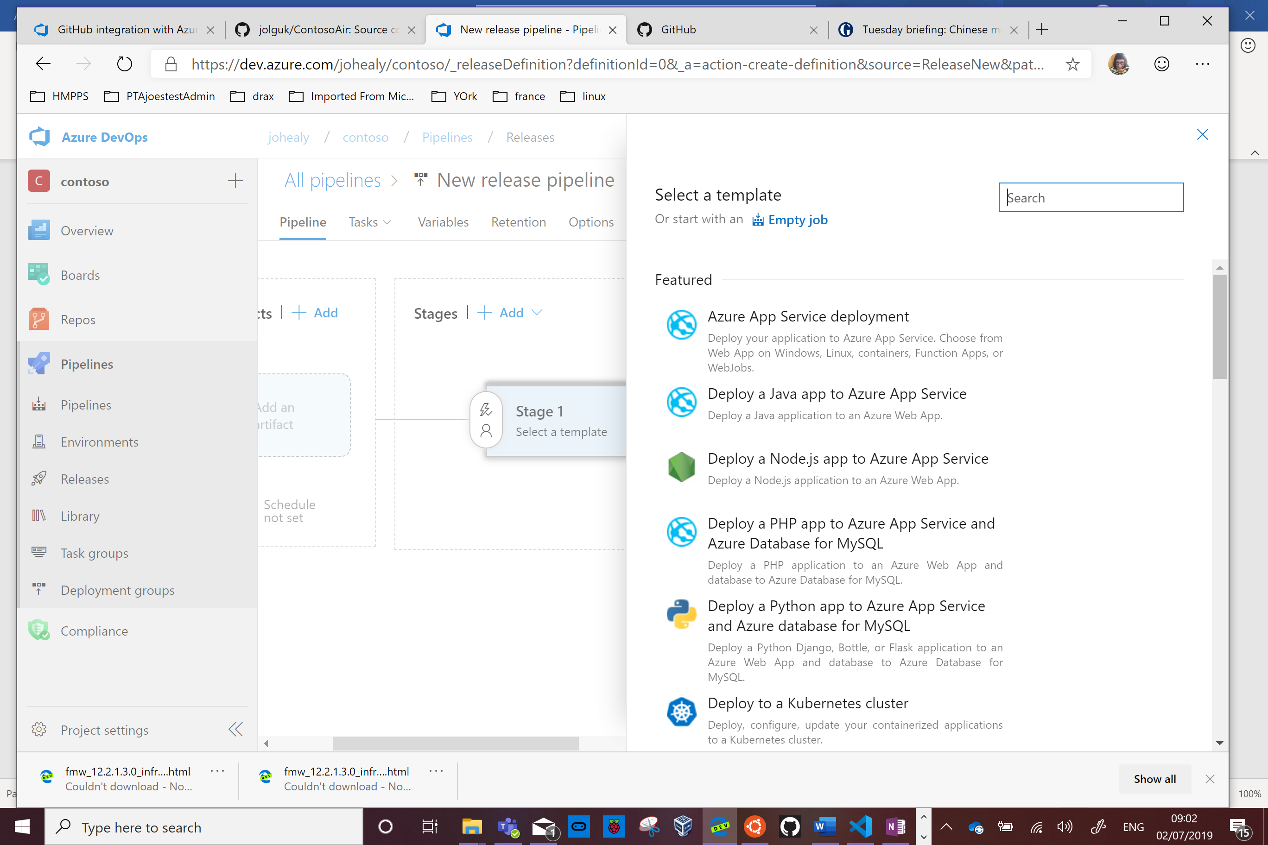



Close the Stage dialog box then click the plus sign next to Artifacts

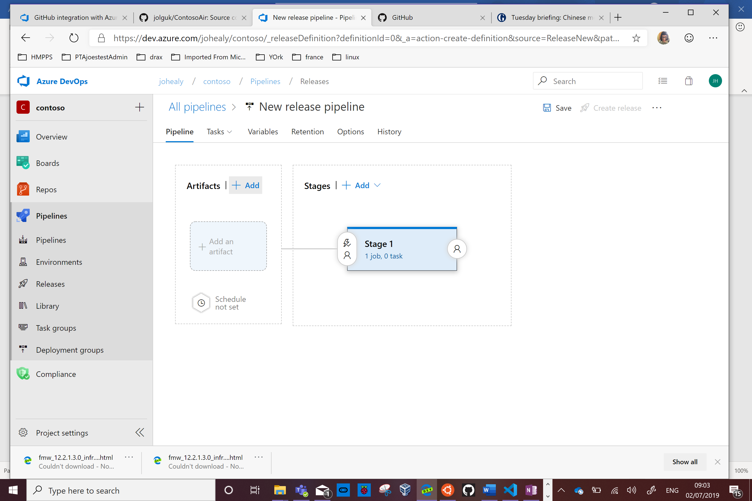

Add the build pipeline you just created by selecting it in the Source dropdown box

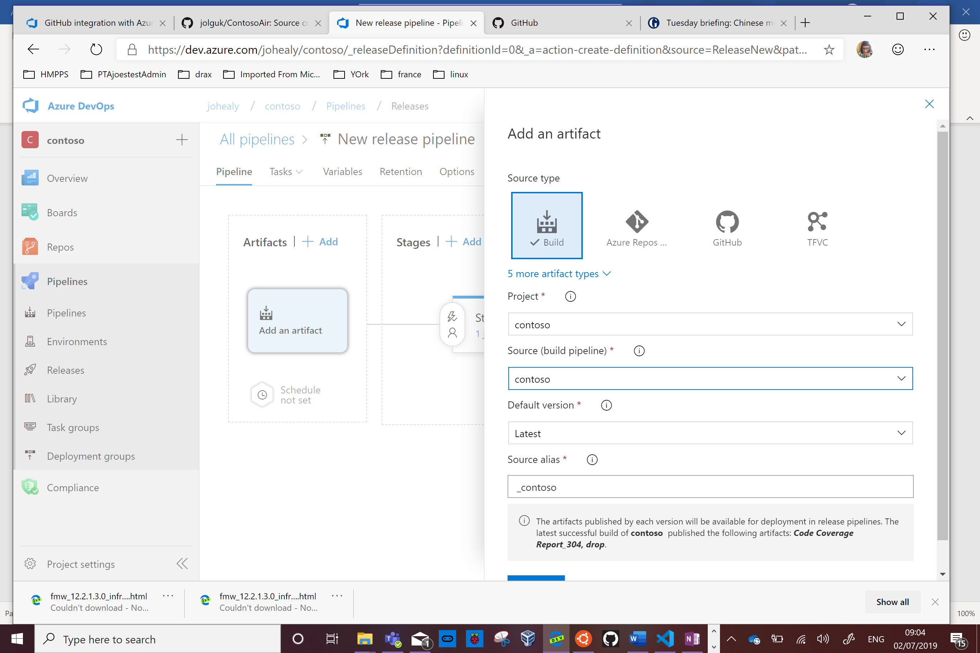

Press Add.

Click 1 job, 0 task

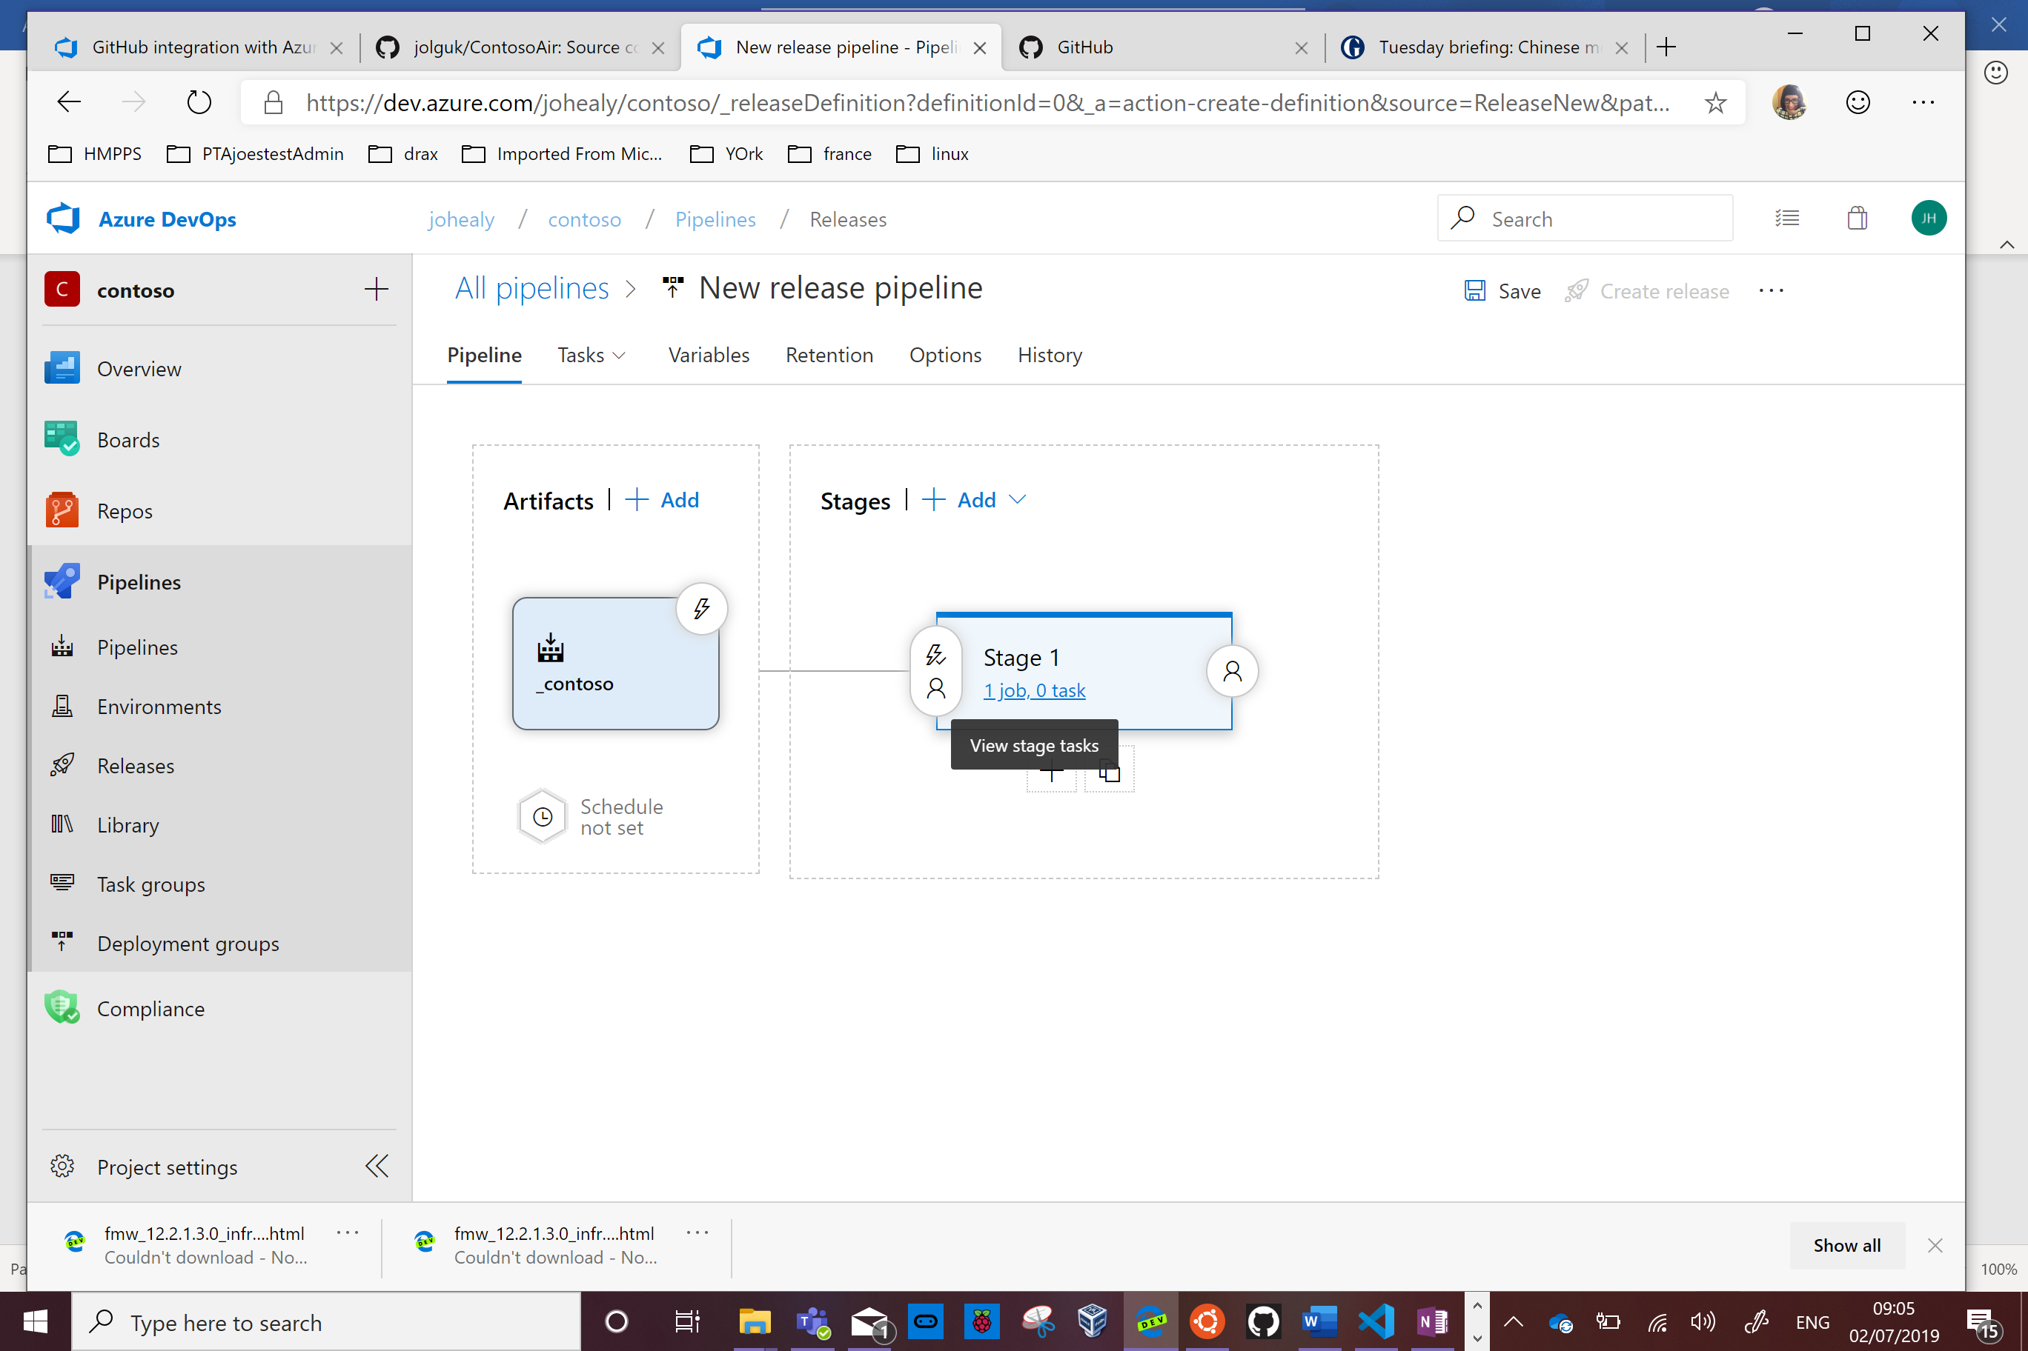

Now add some tasks to the pipeline

Click the + sign

Type res in the search box and select Azure Resouce Group Deployment

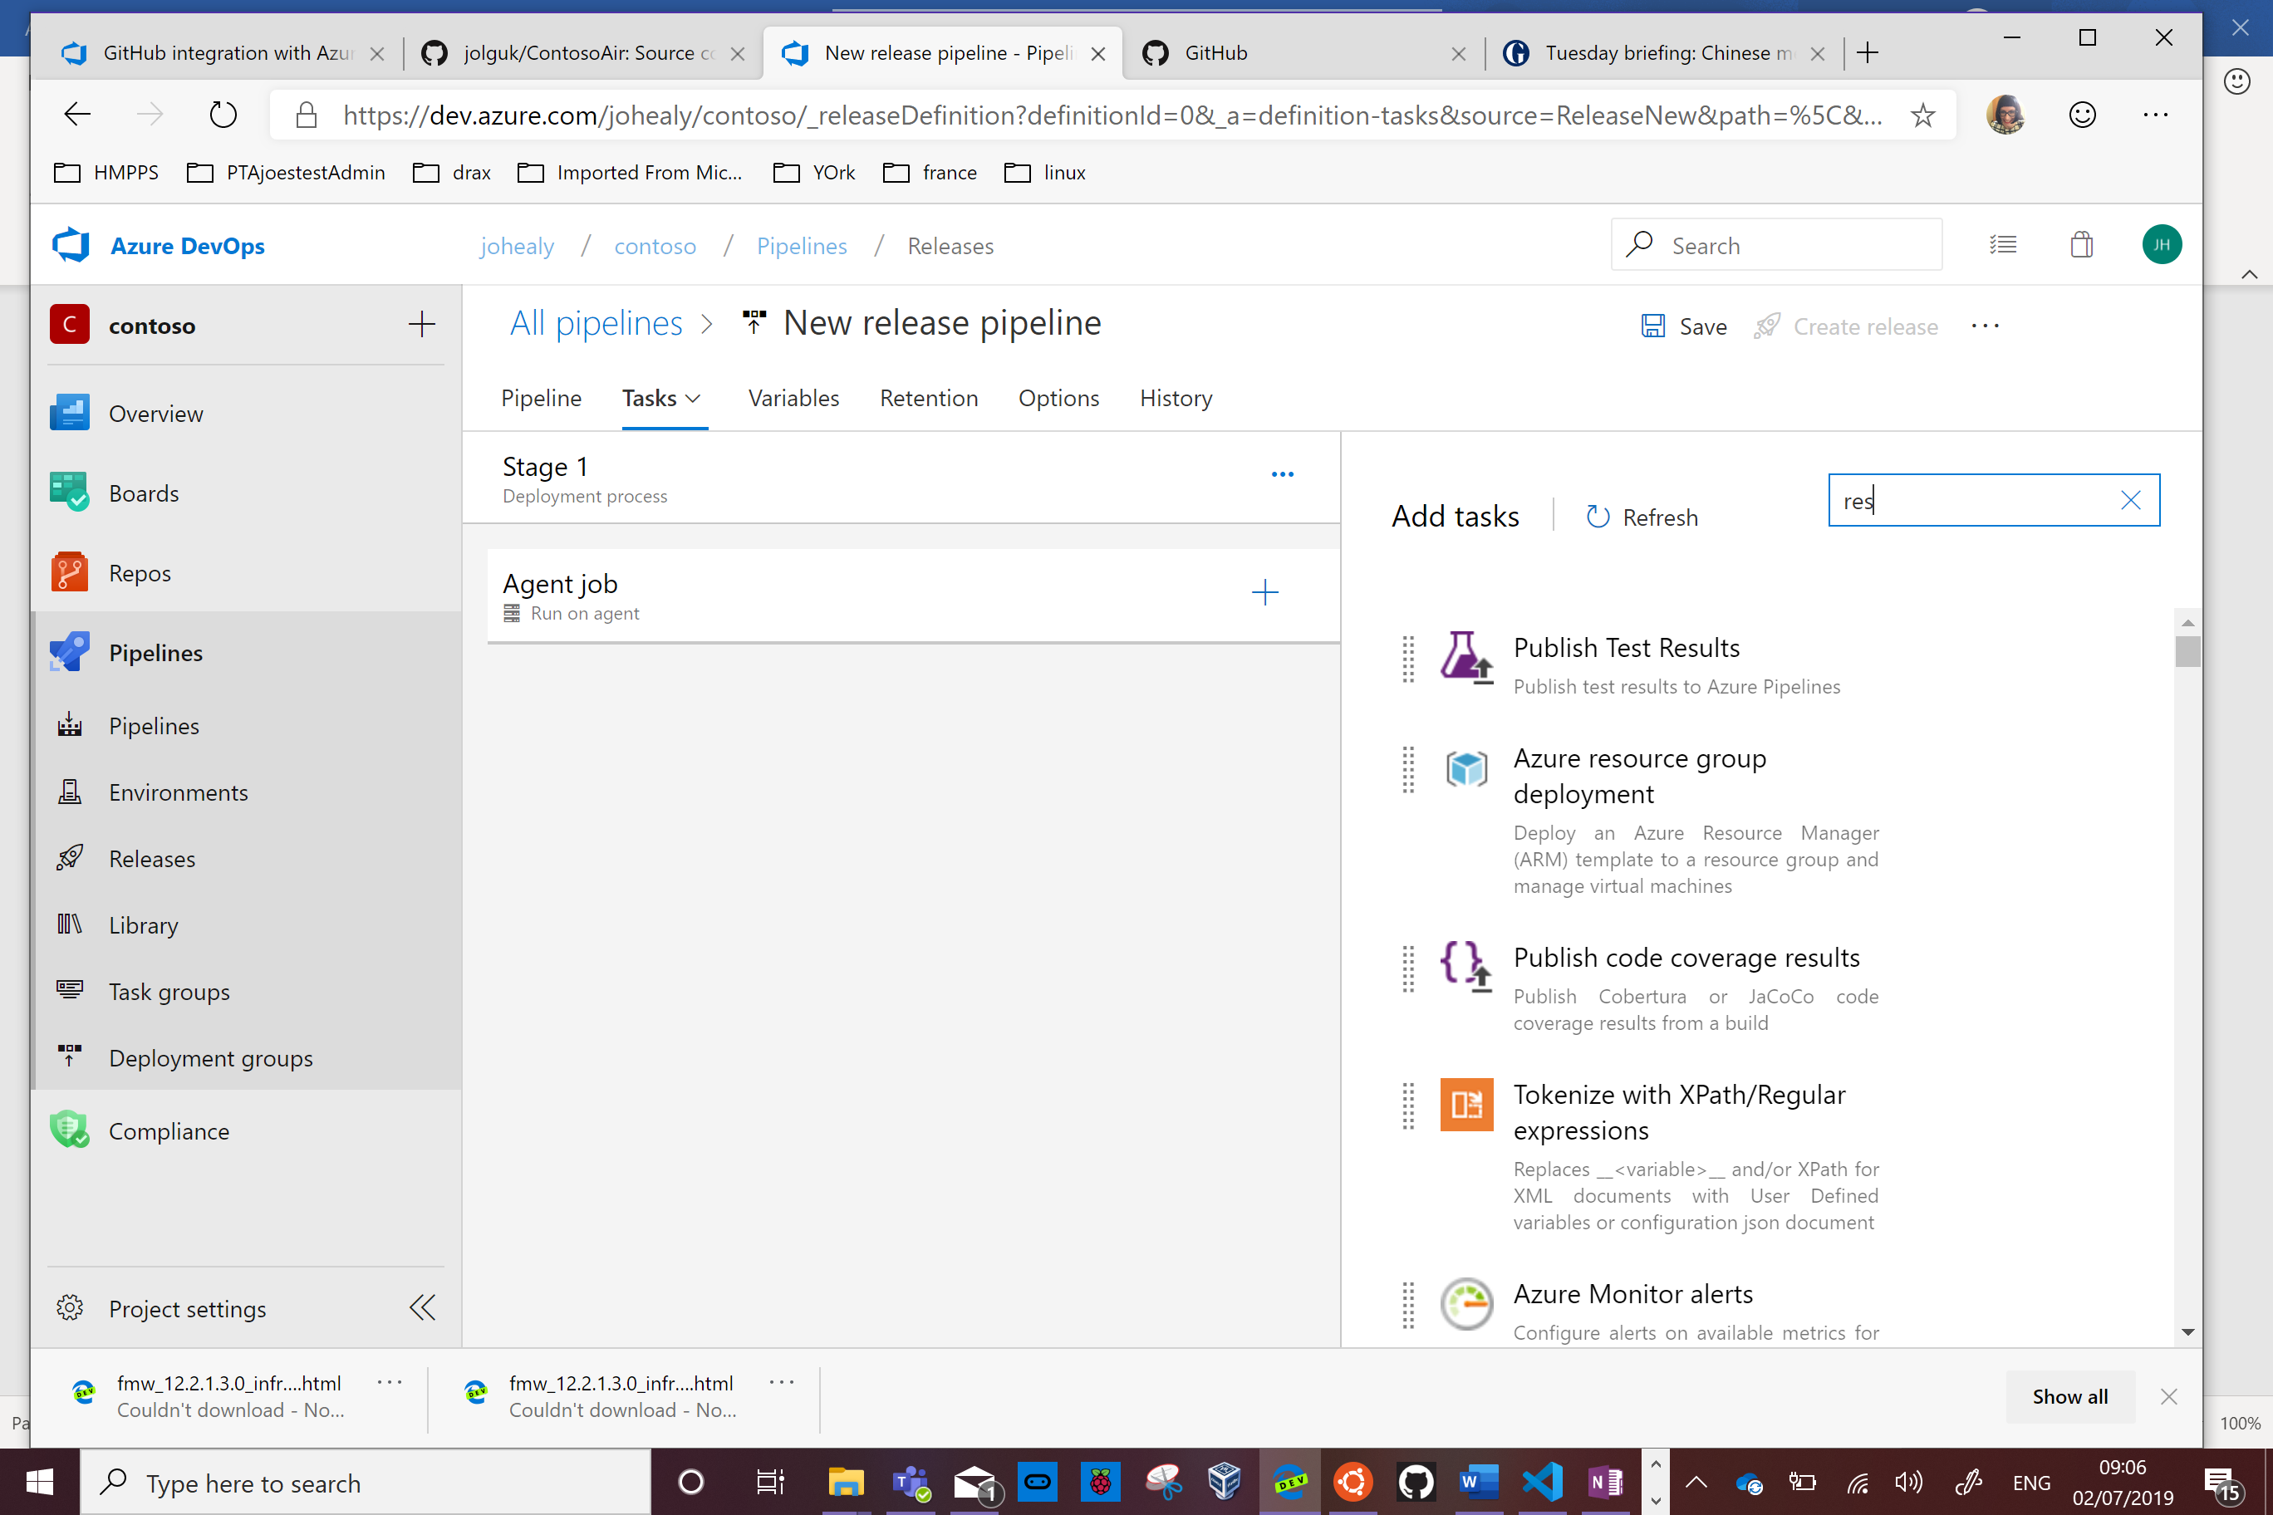

Press Add

Click on the red Some Settings Need Attention link. Now fill out the details of your azure account. Select it from the dropdown box and click Authorise.

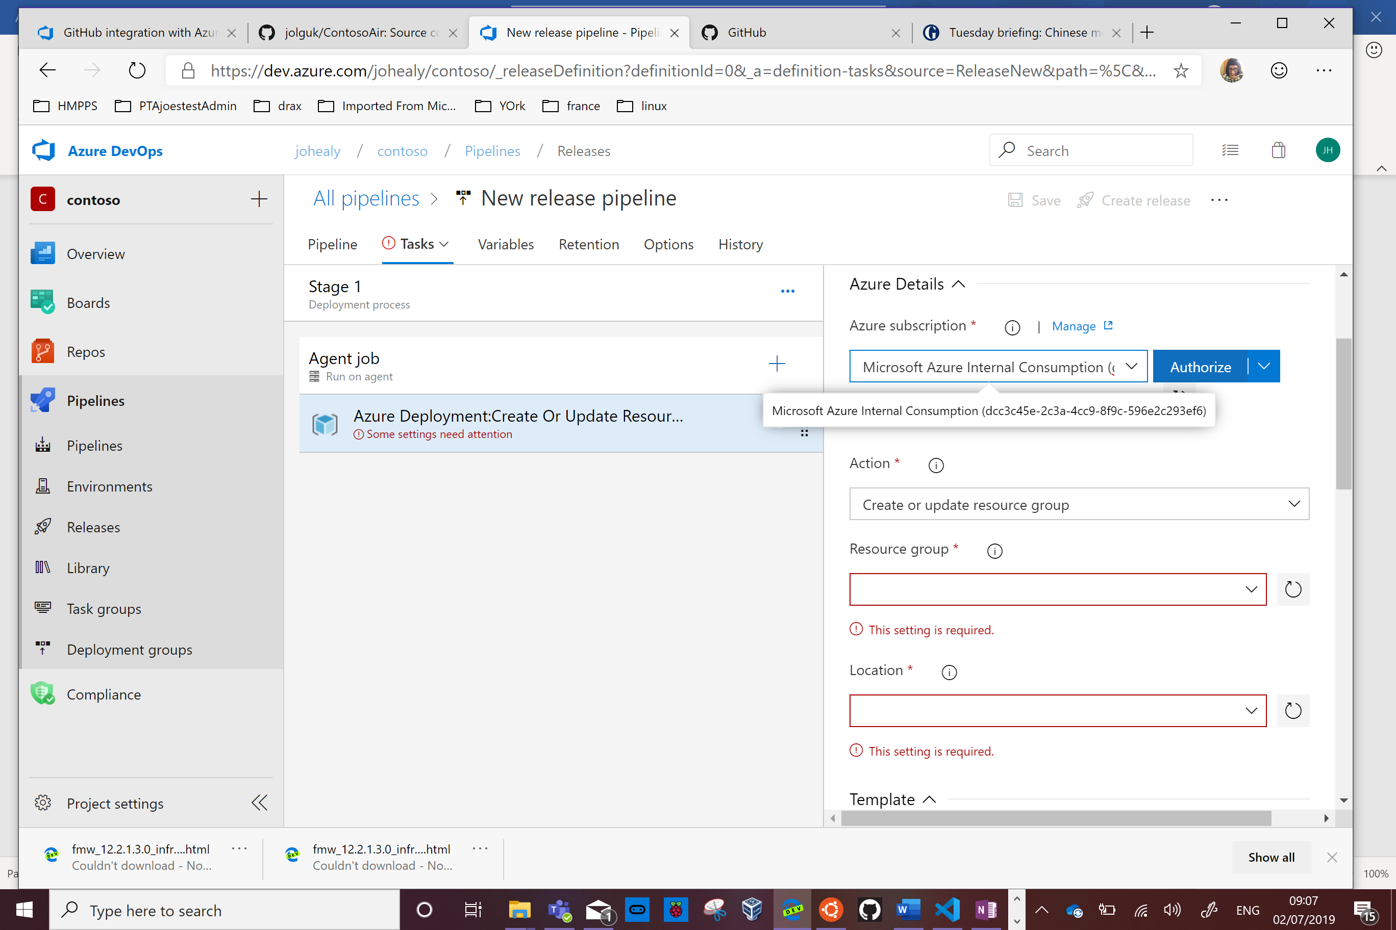

Click on the Variables tab and add a variable for the resource group

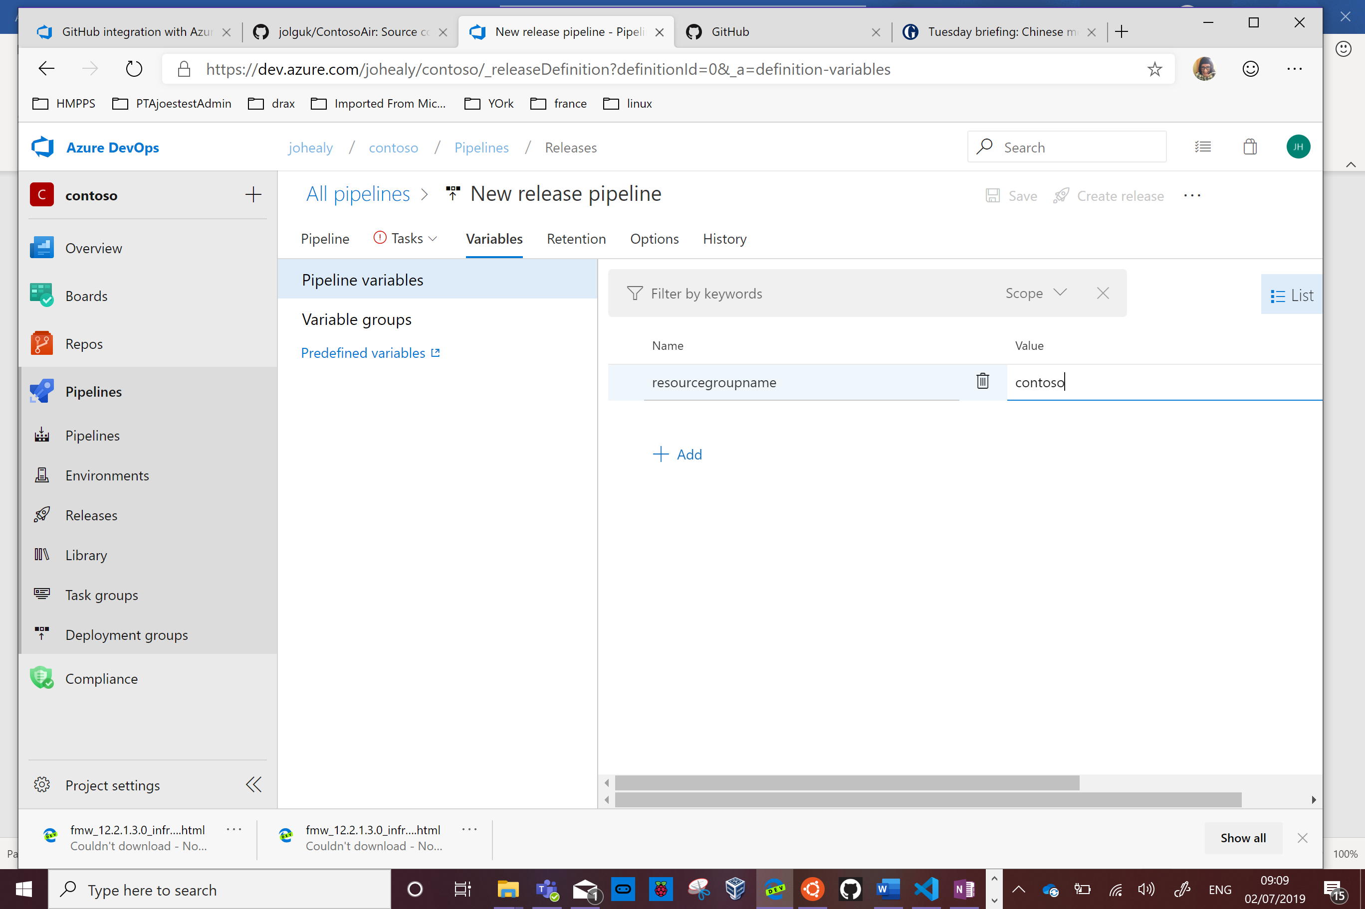

Now click back to Tasks and put $(resourcegroupname) in the Resource Group box and put your desired data centre location

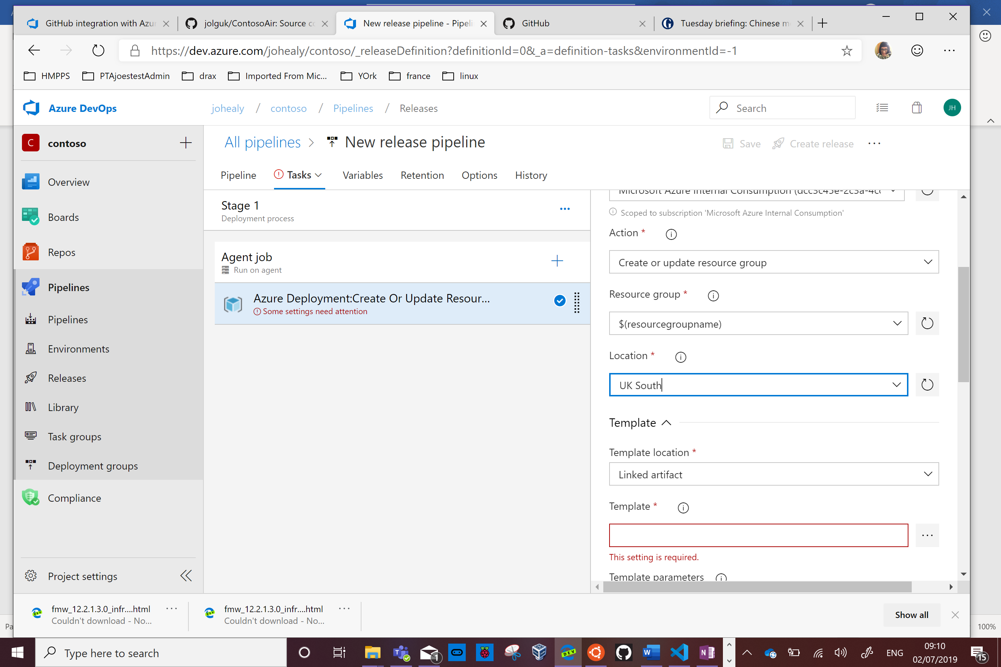

Click on the ellipsis next to Templates and select the ARM template contained in your repository which deploys to an Azure App Service

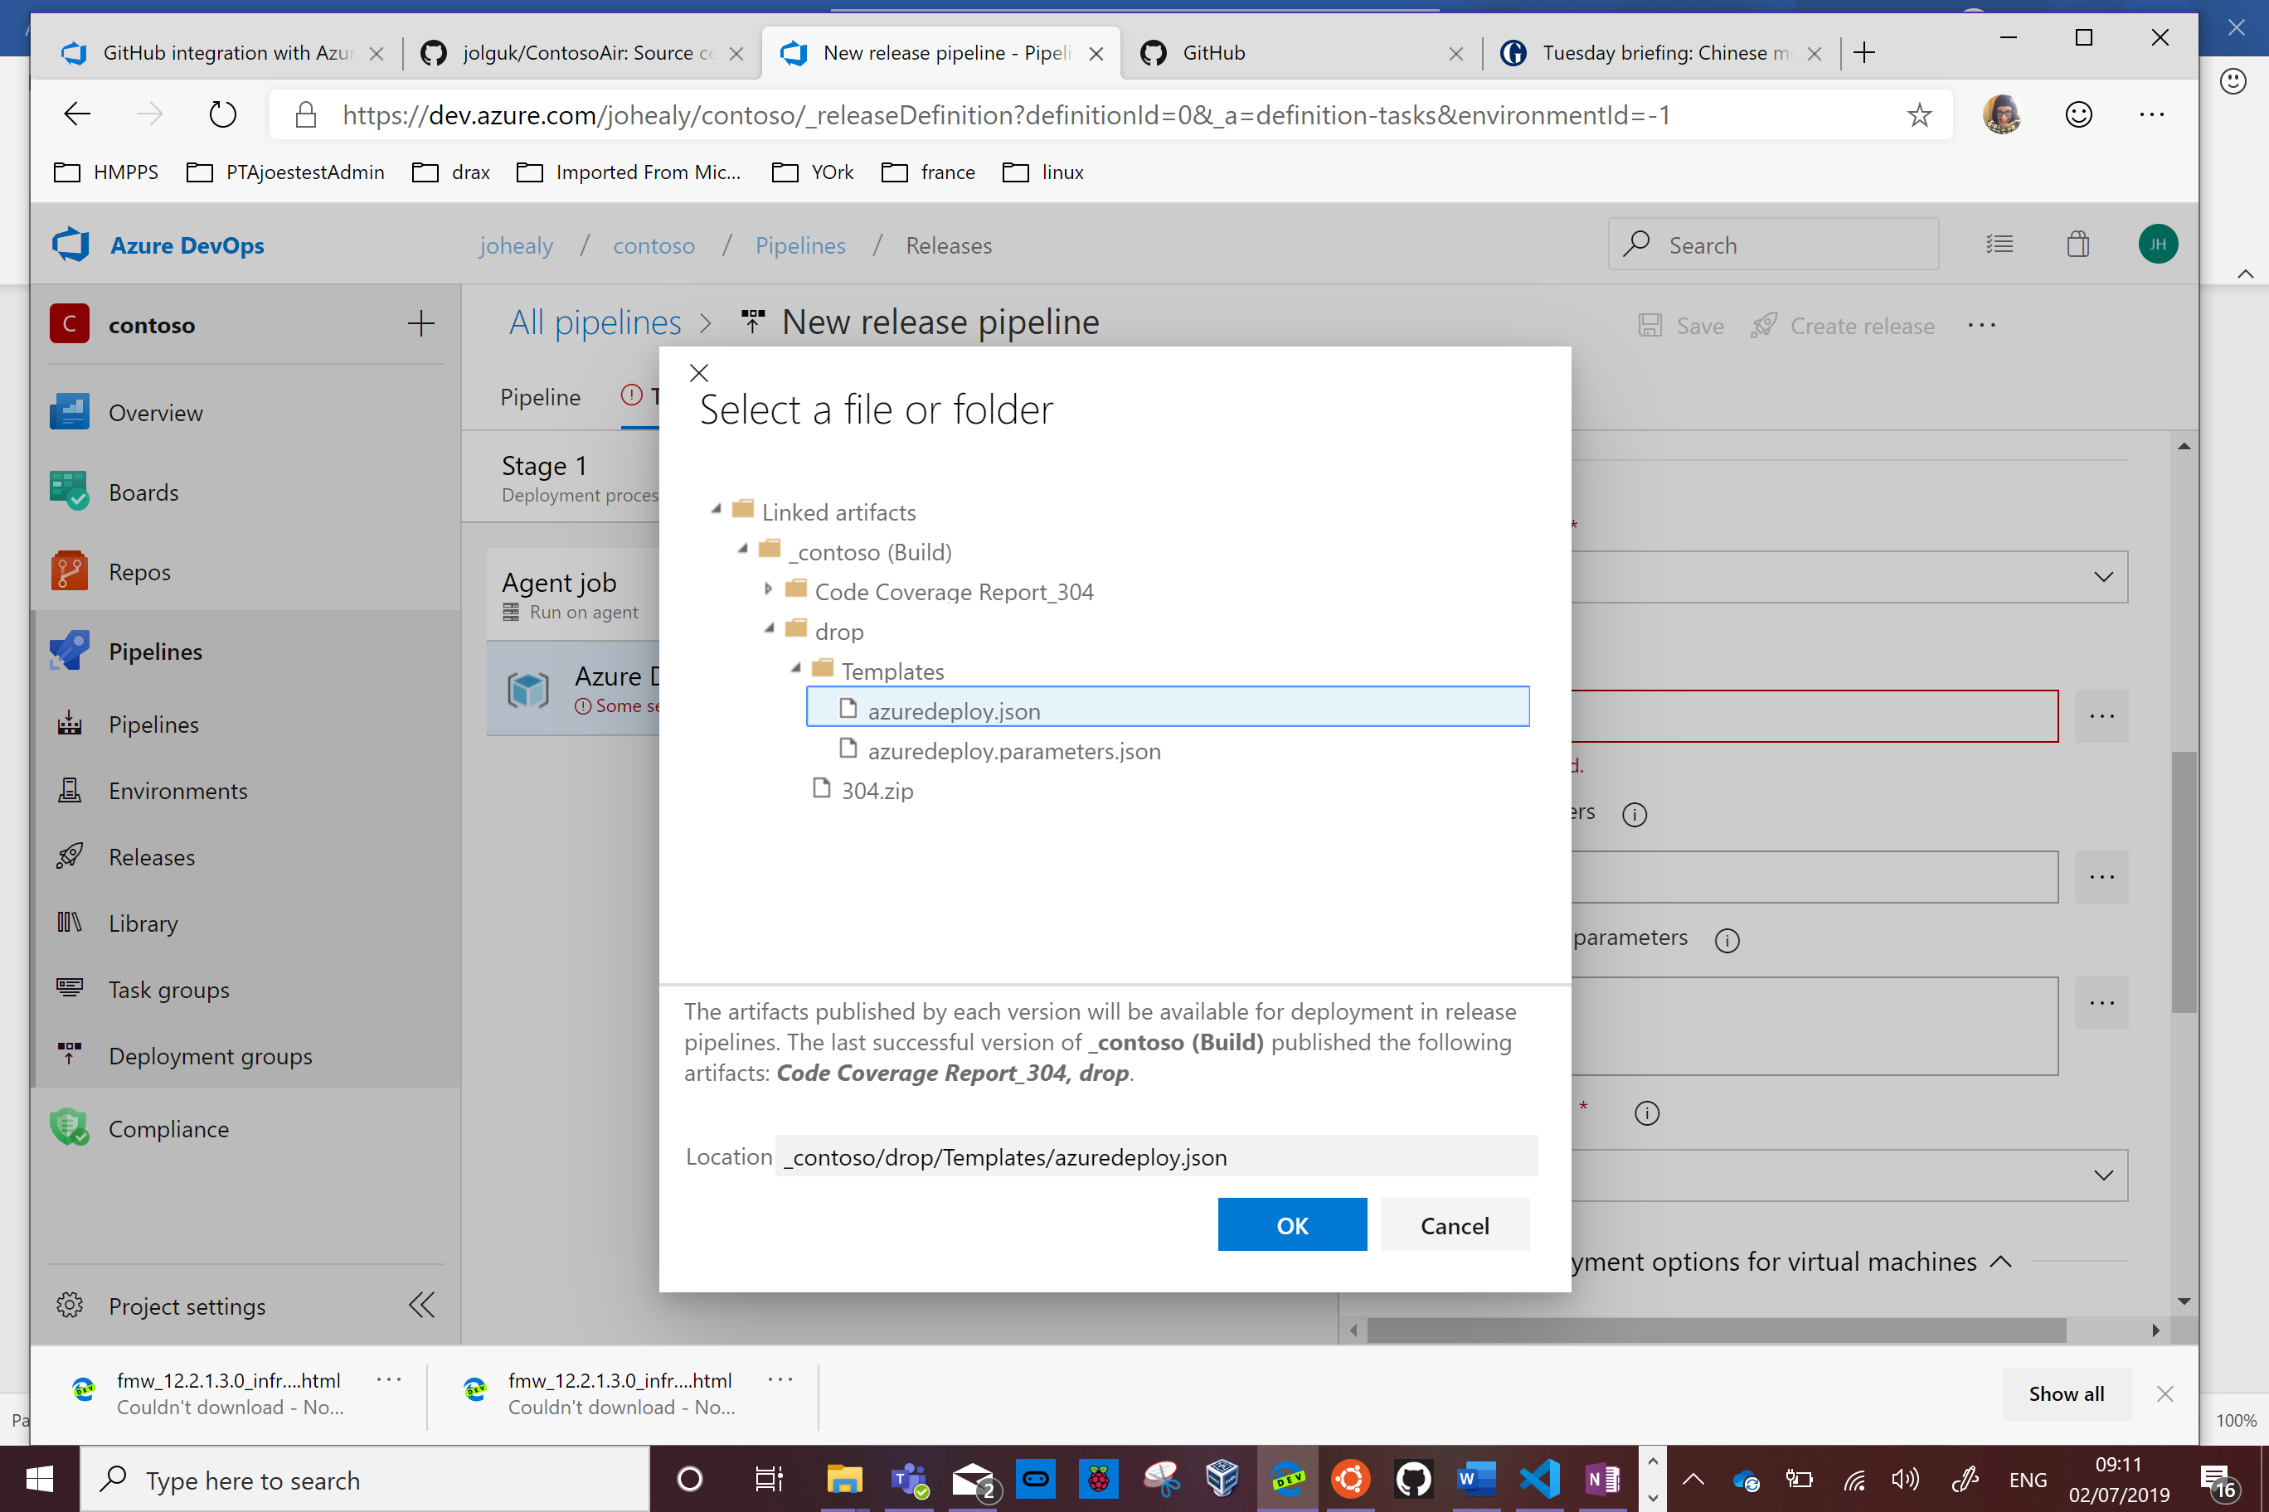

Press Ok. For Parameters select the parameter file in the same folder

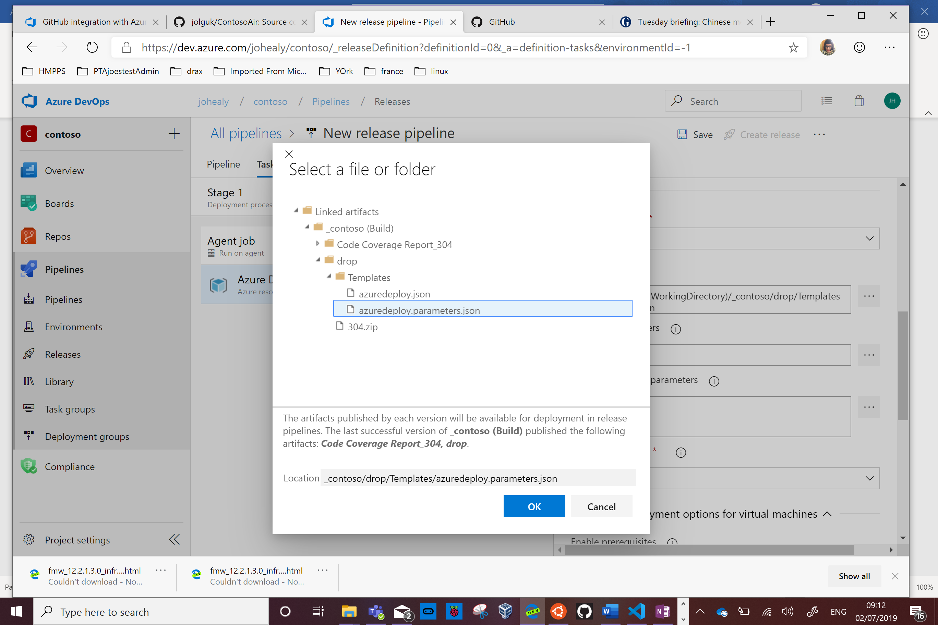

In the Override box type -p_environment with a unique string, since this will be the name of your webapp

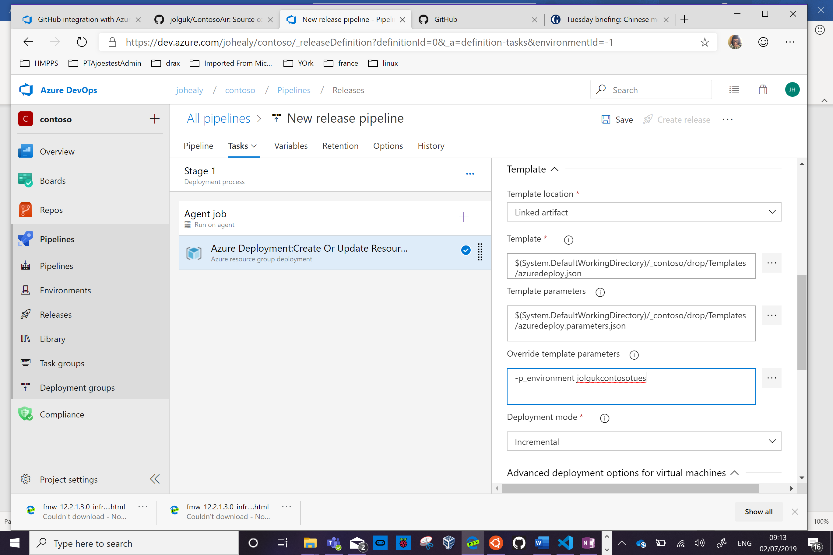

Press the + sign to add another task

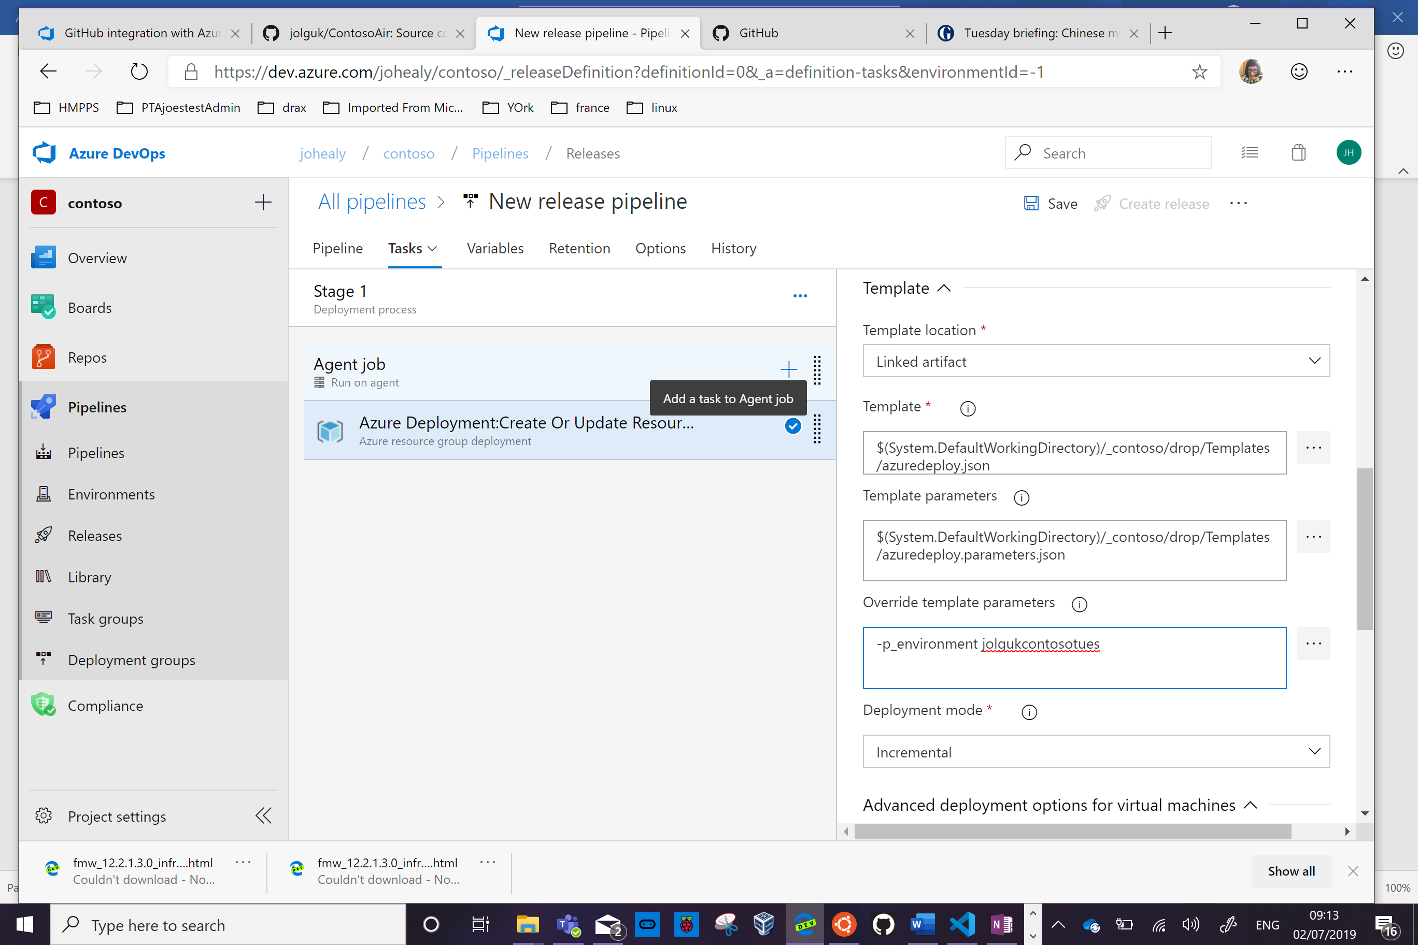

Type ARM in the search box and select ARM Outputs

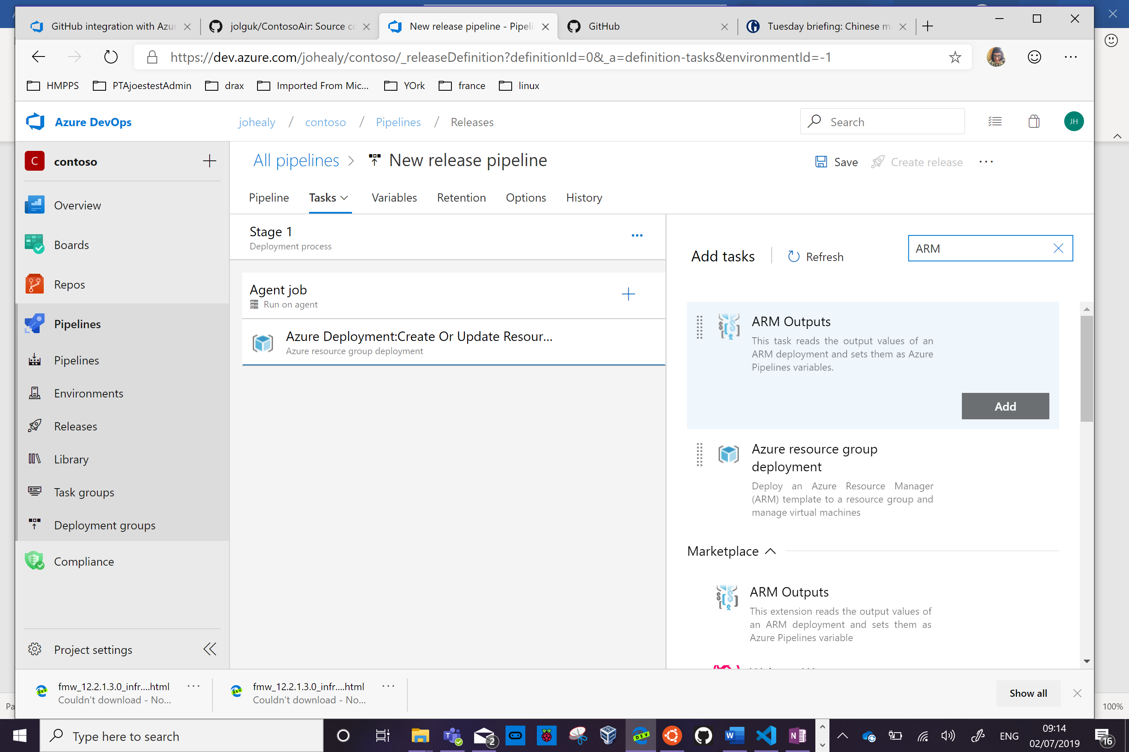

Press Add

Again click on the red Some Settings Need Attention link and fill out the Azure account and the Resource Group 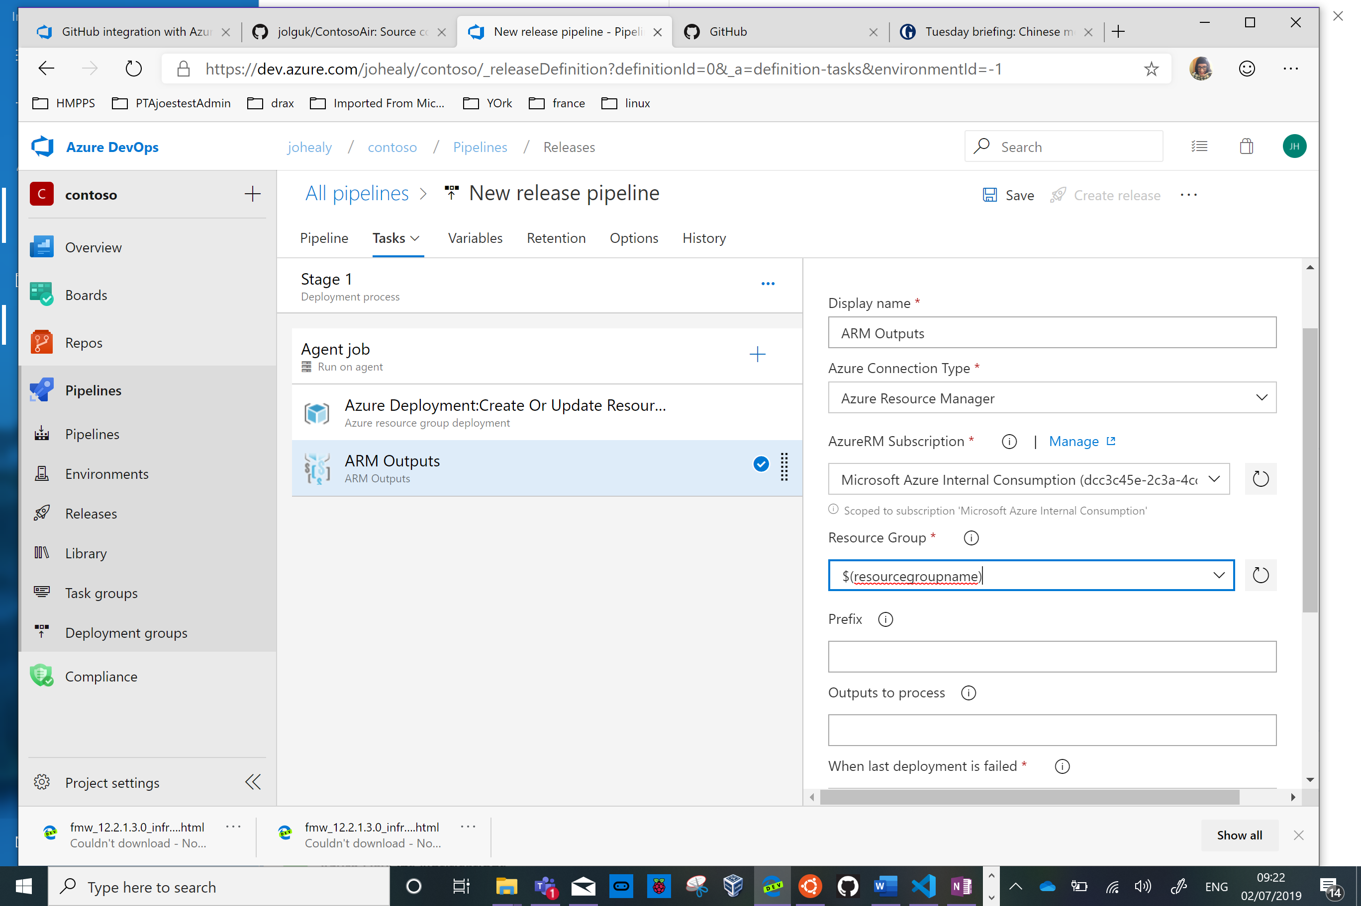

Press the + again to add a final task, put App Service in the search box and select Azure App Service Deploy and click Add

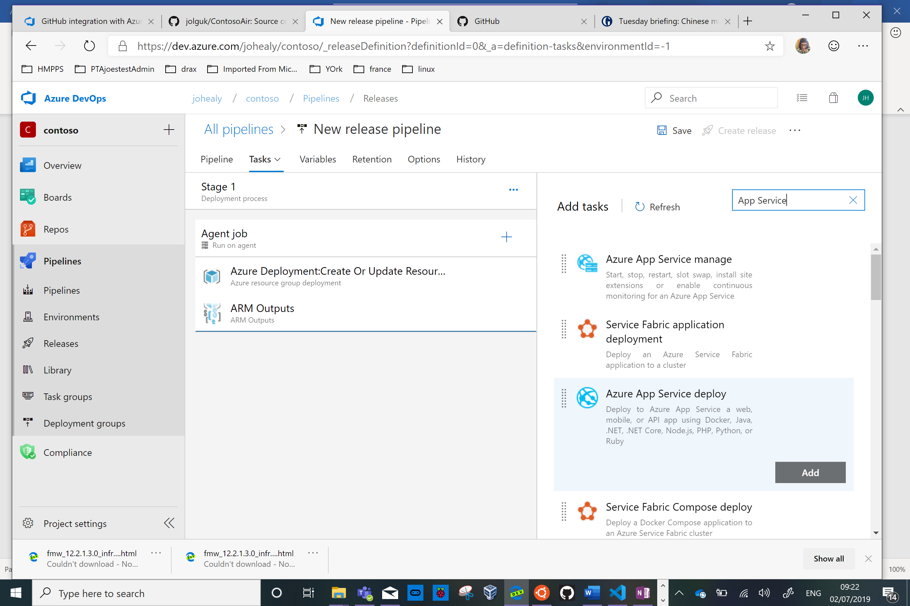

Fill out the subscription and $(web) for the App Service name (this will take it from a variable generated in the previous step).

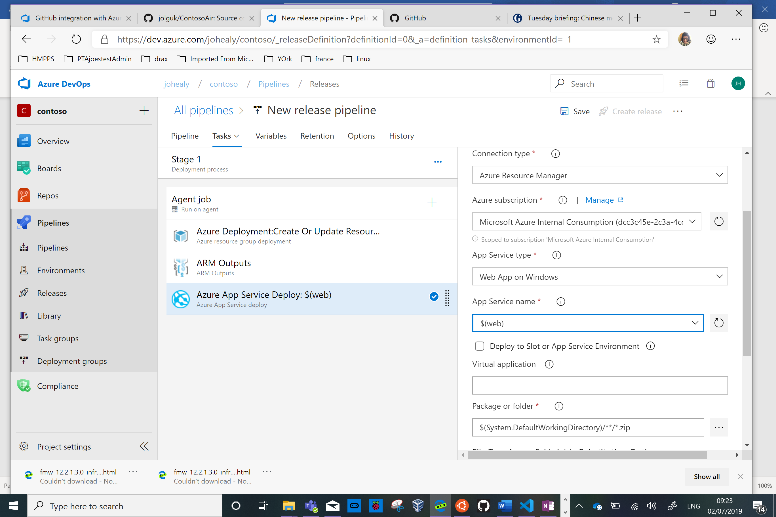

Press Save and Ok (add a comment if you wish)

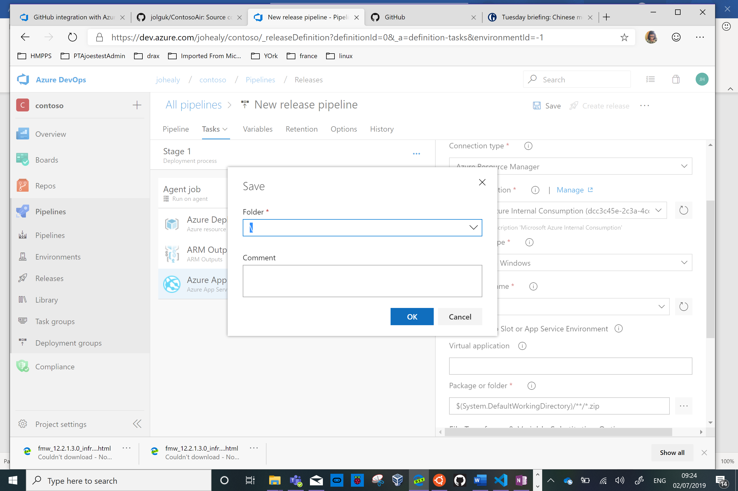

Now press Create Release

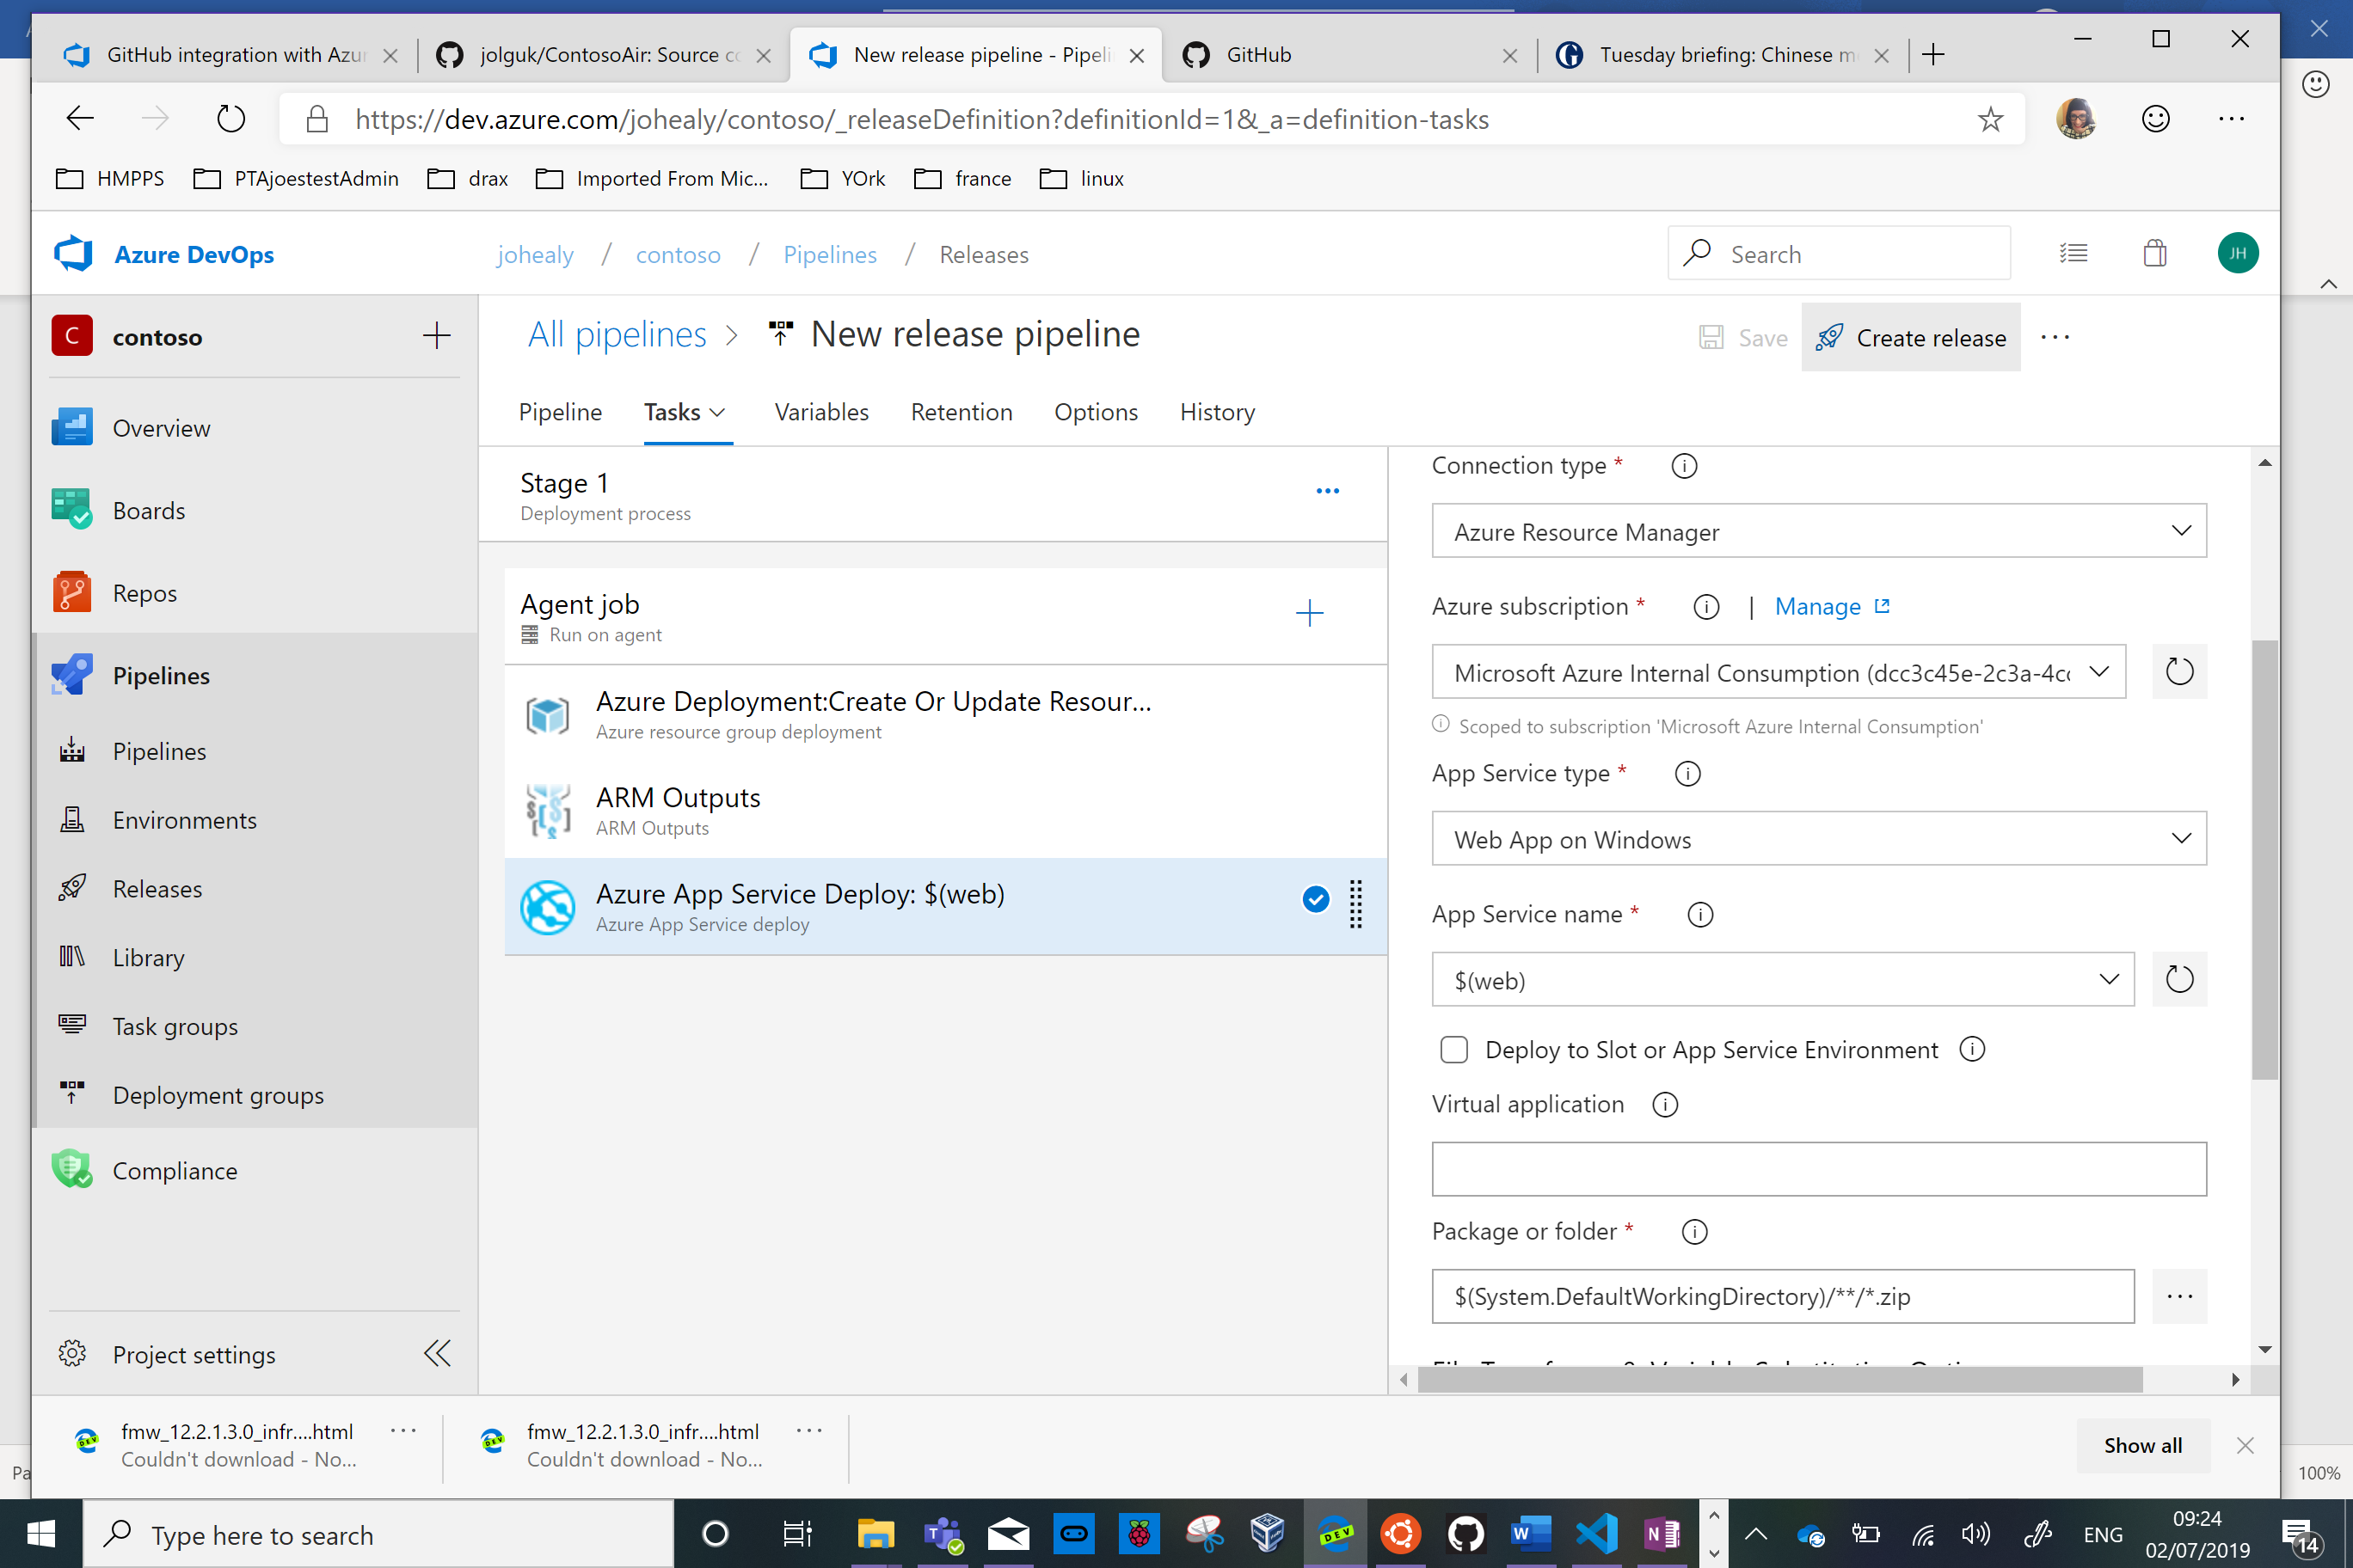

Press Create

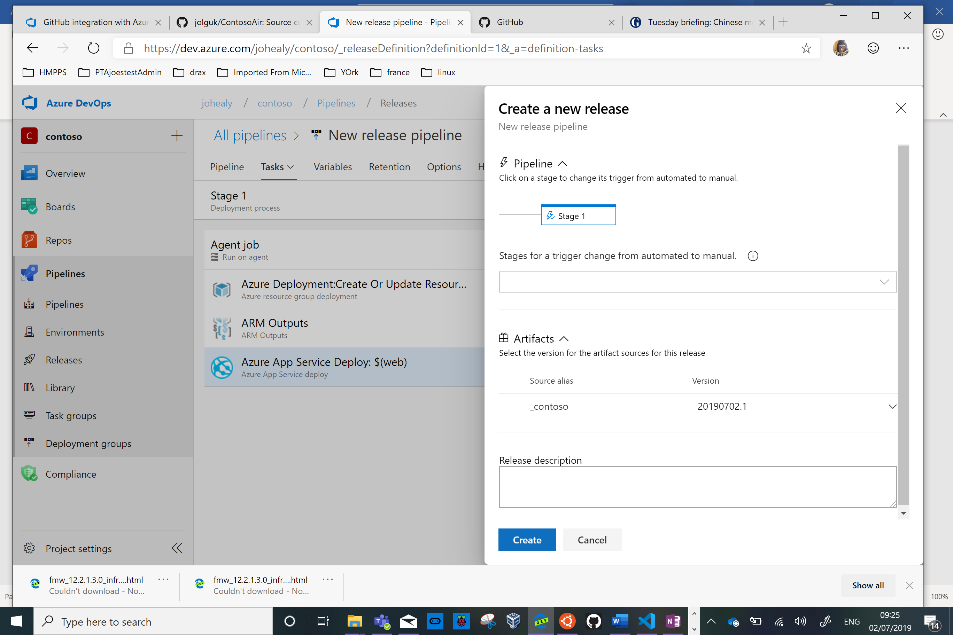

Now click on Release-1 to follow progress of the deployment

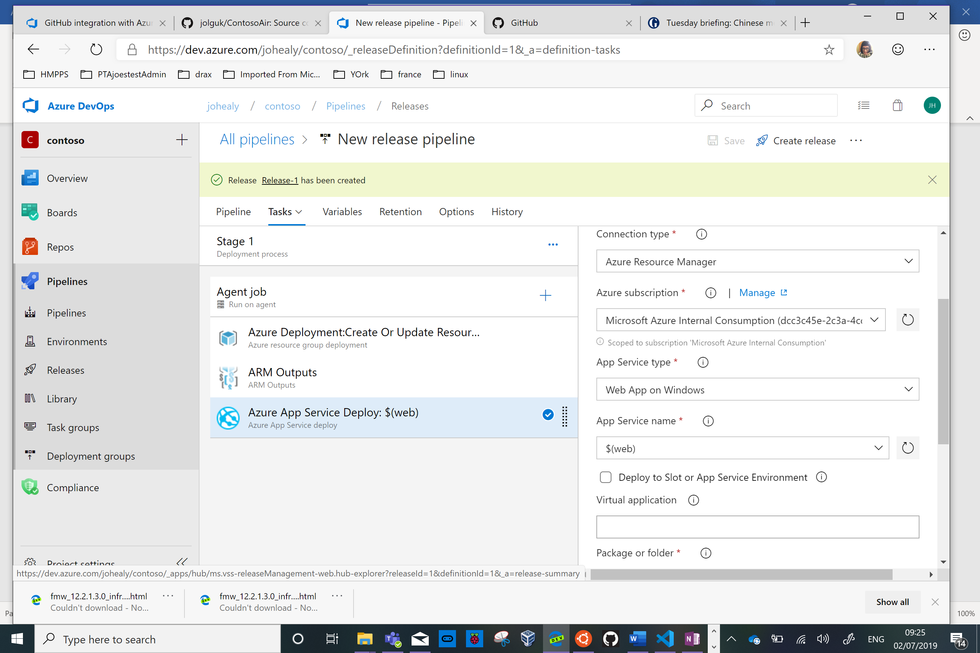

Click Logs for more detail

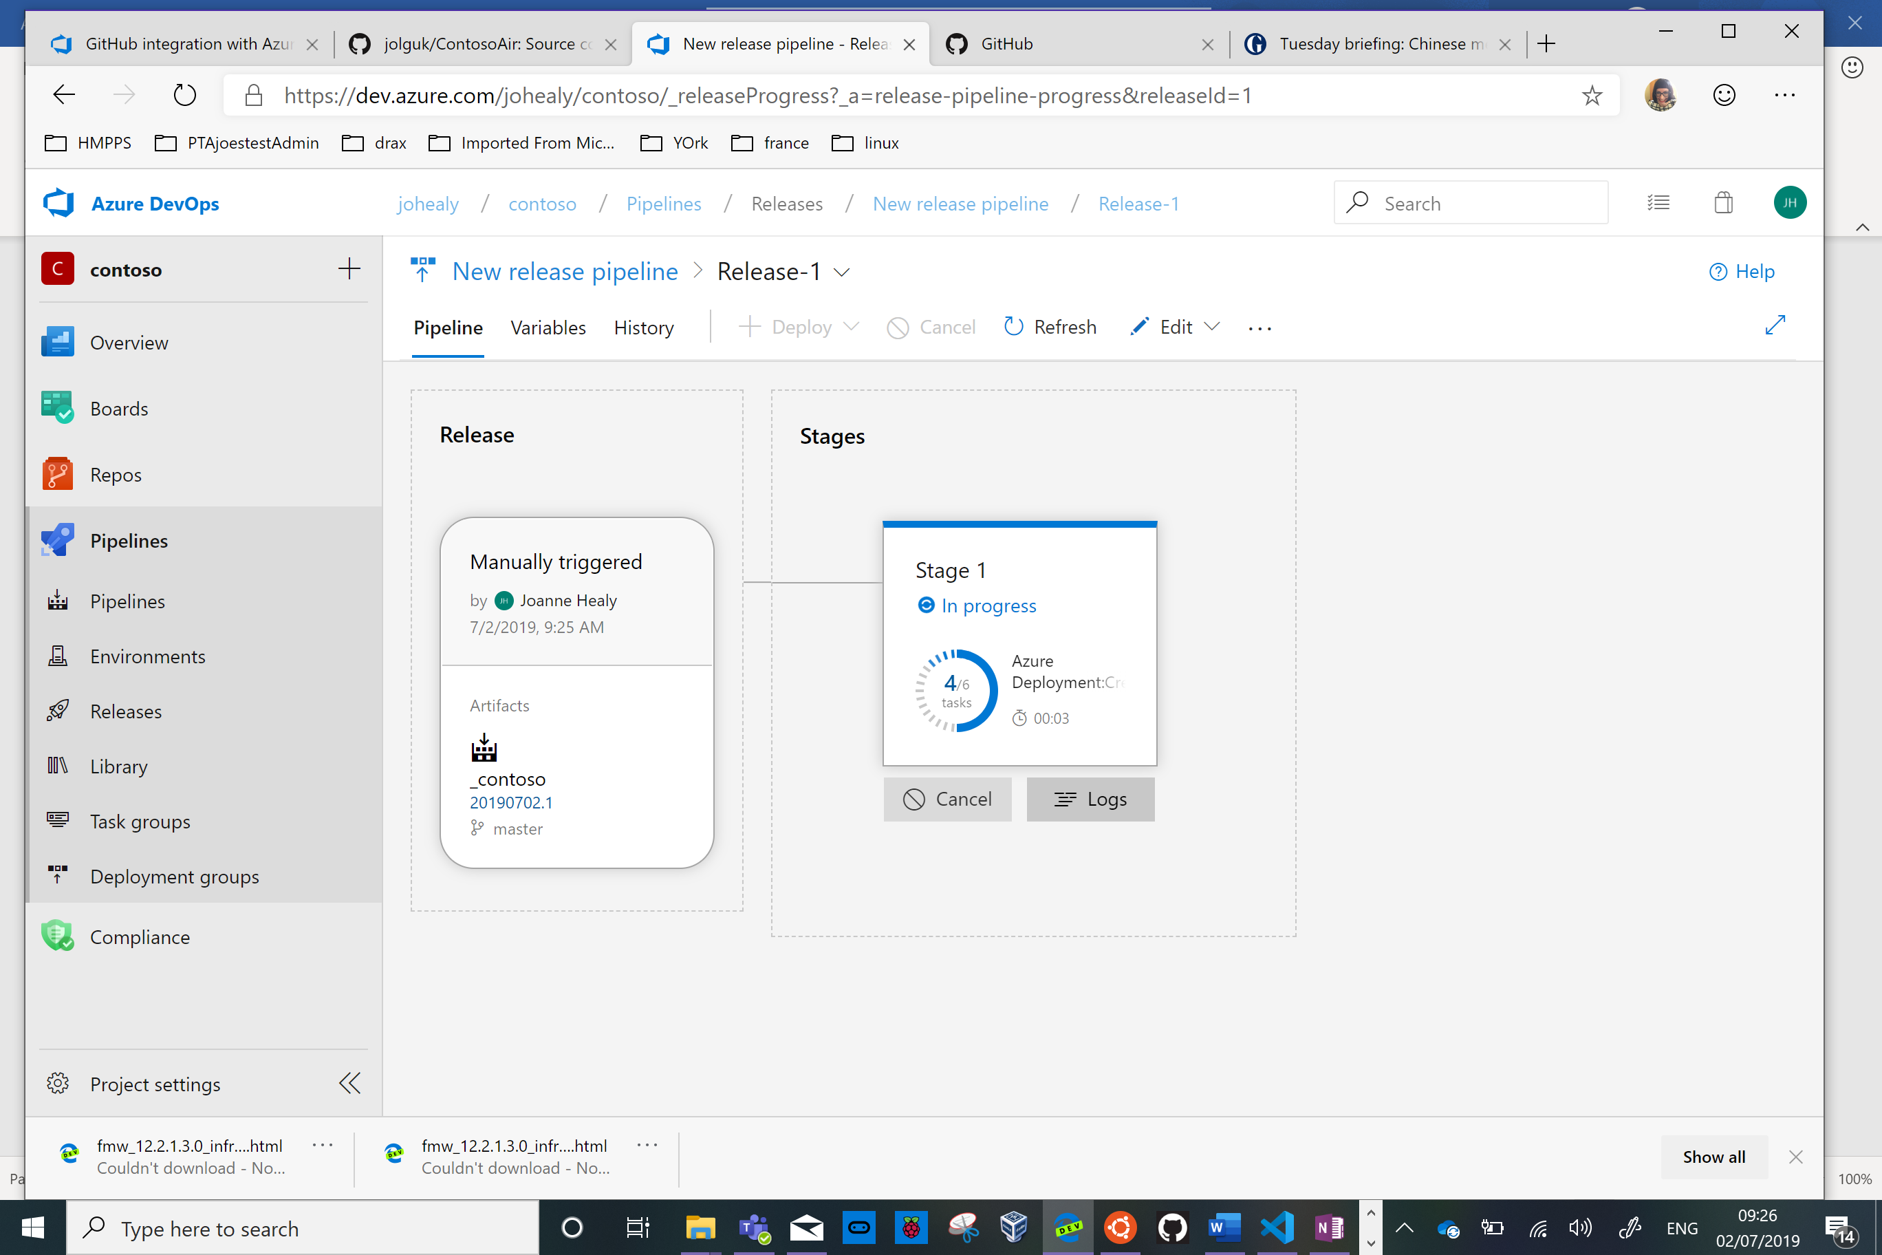

Once it’s finished click on the App Service Deploy stage

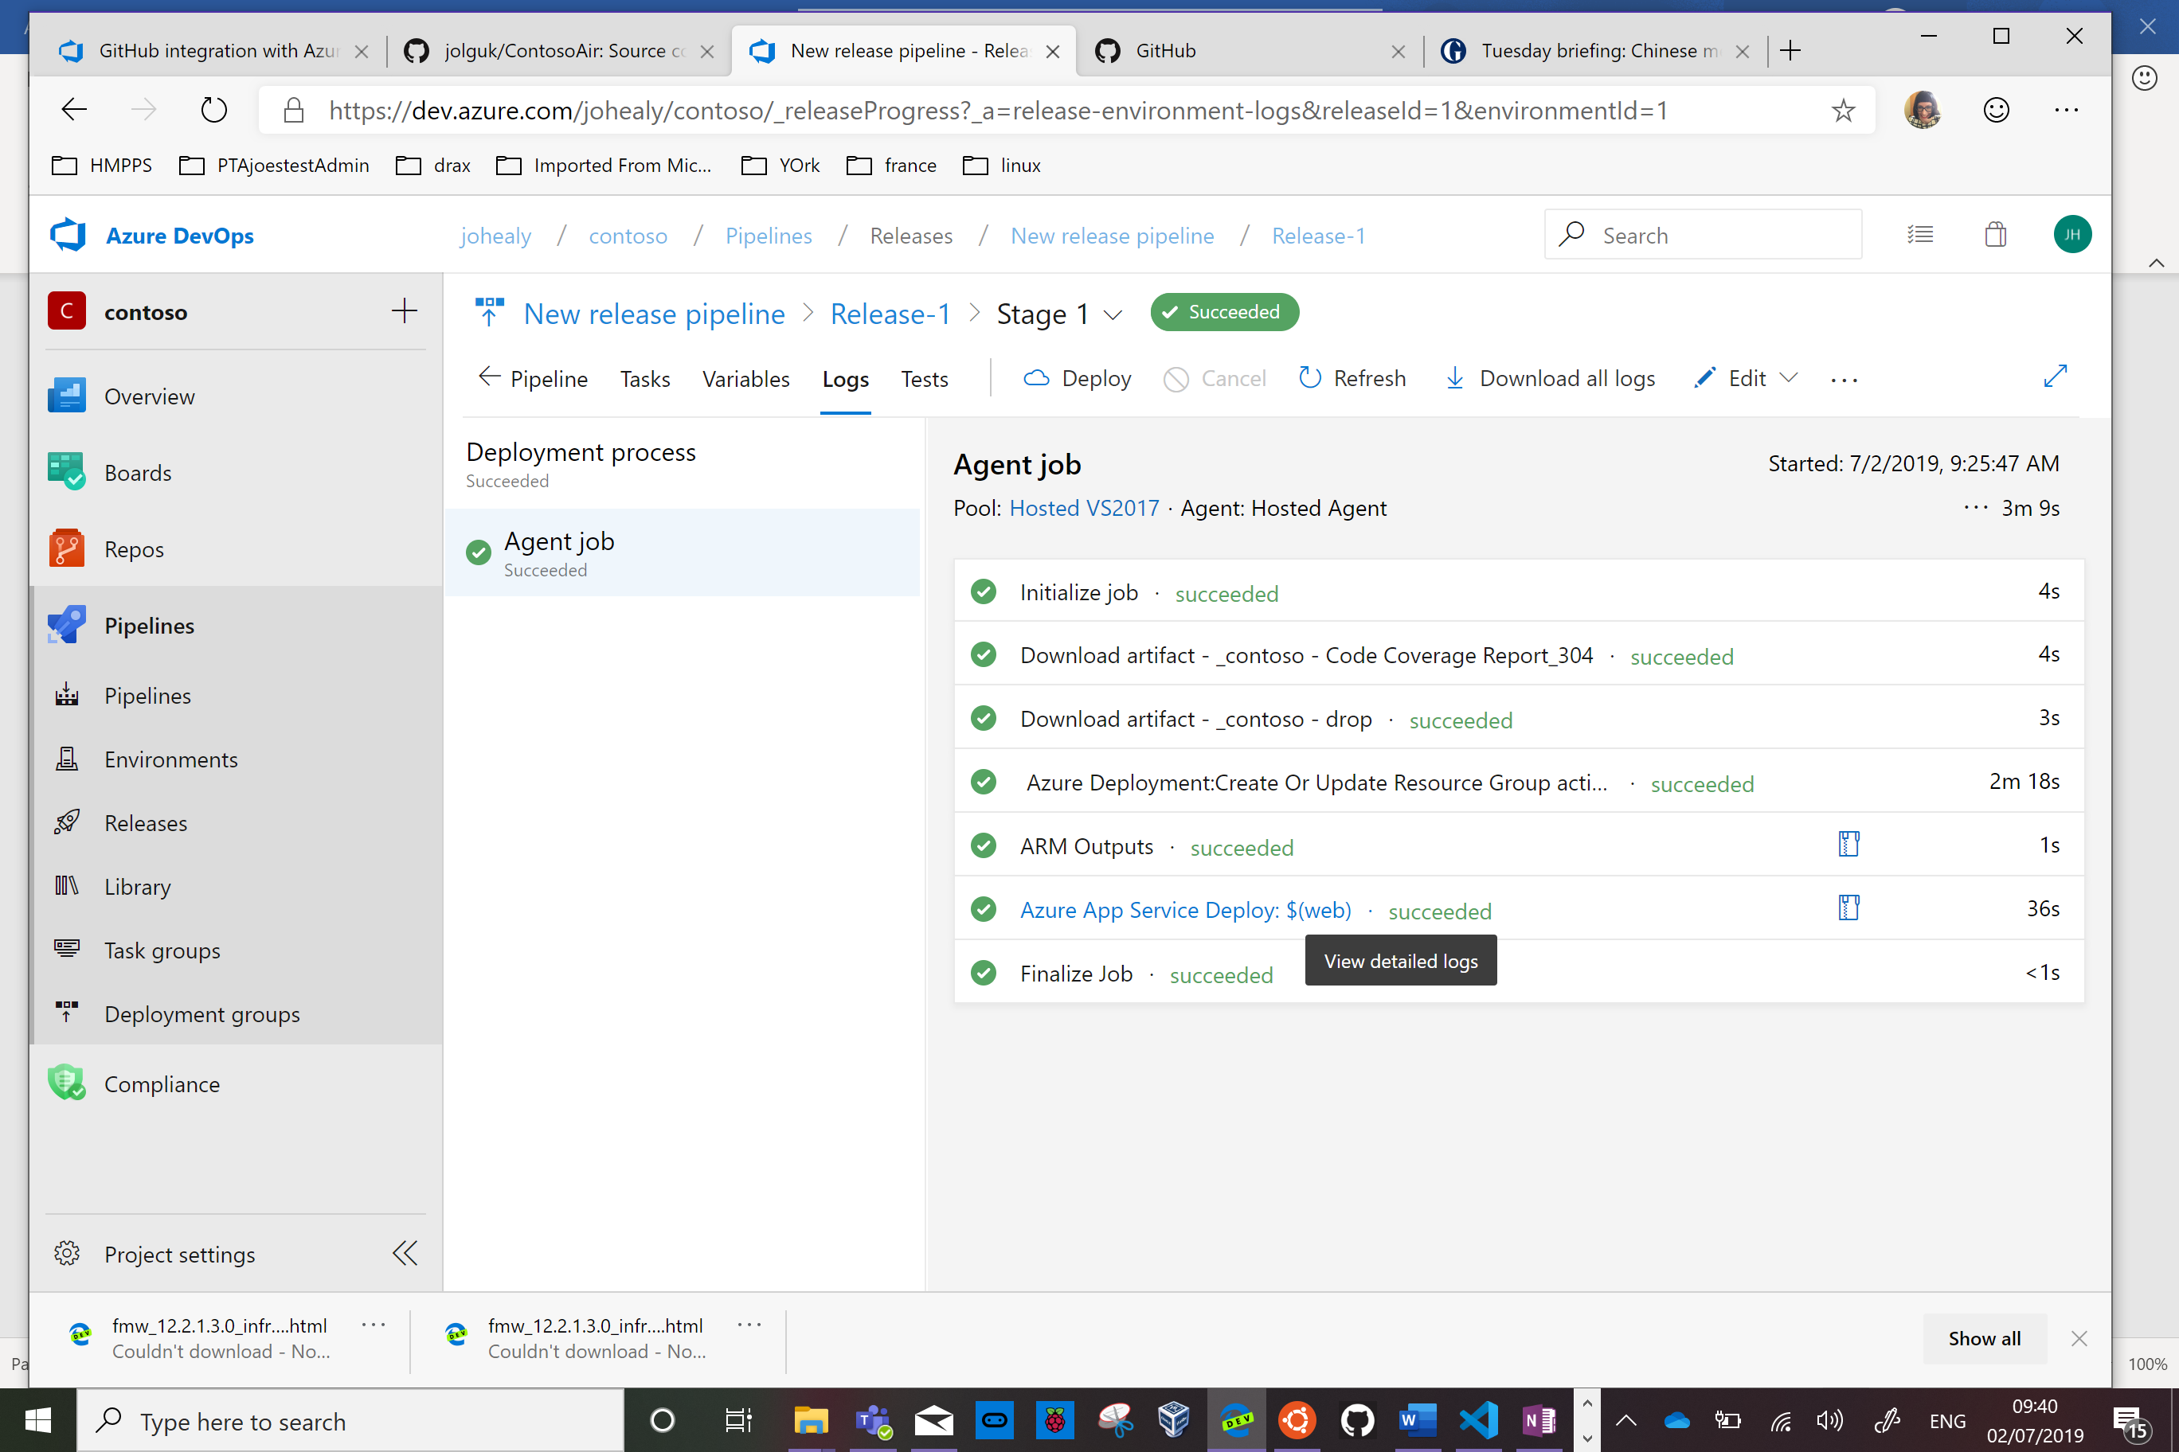

Copy the URL for the website generated

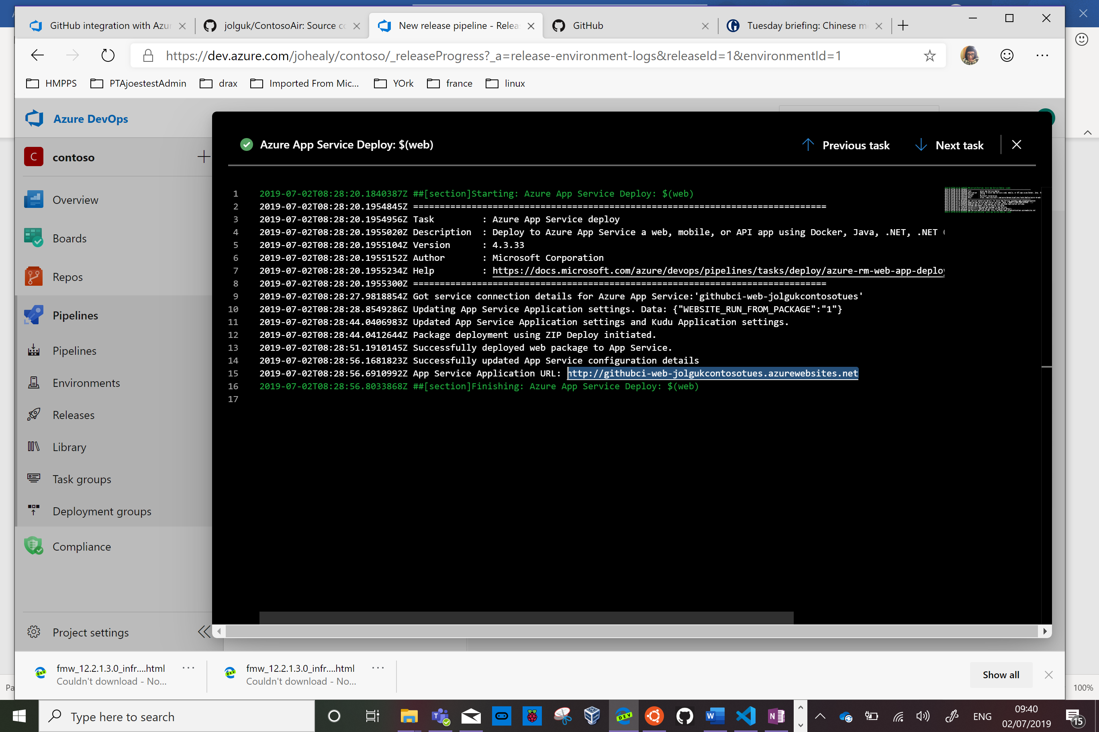

Browse to that site

